1

MAKING THE START LIST FOR CRUDEN BAY 2025.

BEGIN WITH THE CB TEMPLATE FOR CB MEMBERS, RENAME IT

“CRUDEN BAY OFFICIAL START LIST 1 MAY 2025” AND SAVE THAT CHANGE OF NAME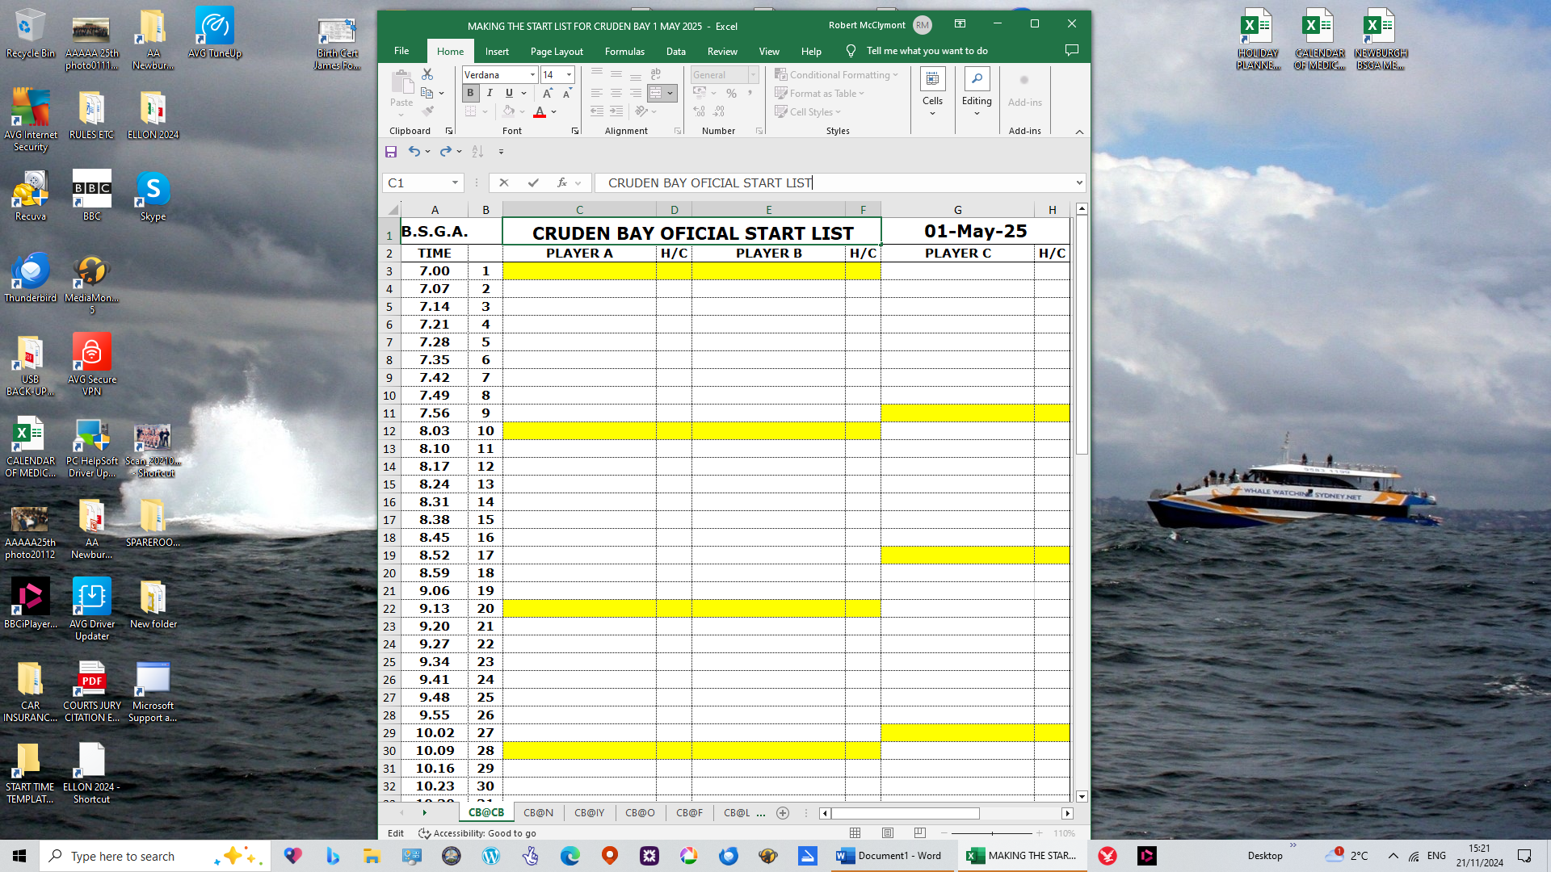

2

SET UP YOUR EXCEL SCREEN WITH THE FRESH OFFICIAL START LIST ON THE LEFT AND THE START LIST SENT BY THE CB REP ON THE RIGHT.

DO A QUICK VISUAL CHECK THAT THE CB ENTERED NAMES ON THE RIGHT FIT OPPOSITE THE YELLOW COLOURED TIME SLOTS ON THE LEFT. IF IT’S OK, PROCEED TO COPY & PASTE.

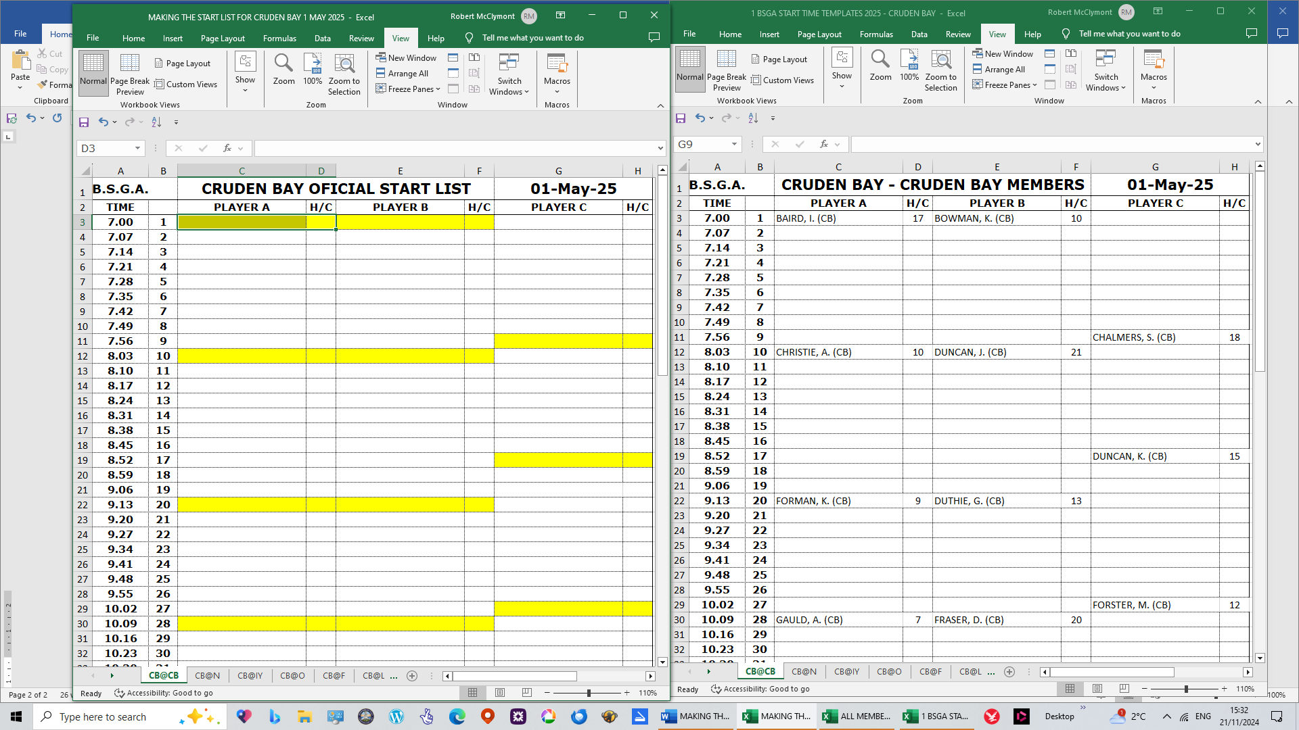

3
HIGHLIGHT THE FULL PAGE SENT BY THE CLUB REP (INCLUDING THE RESERVE TIMES) AND CLICK ON “COPY”.

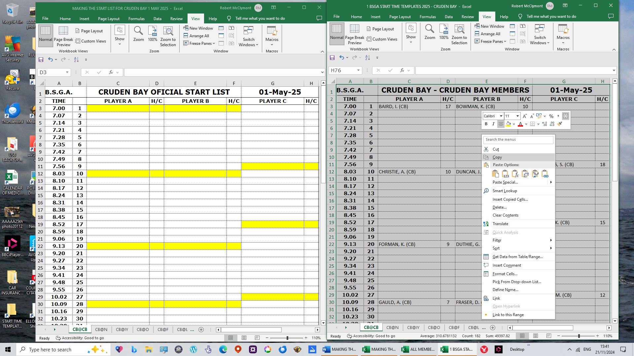

4
HIGHLIGHT THE FULL PAGE OF THE OFFICIAL START LIST (INCLUDING THE RESERVE TIMES) AND CLICK ON “PASTE SPECIAL”.

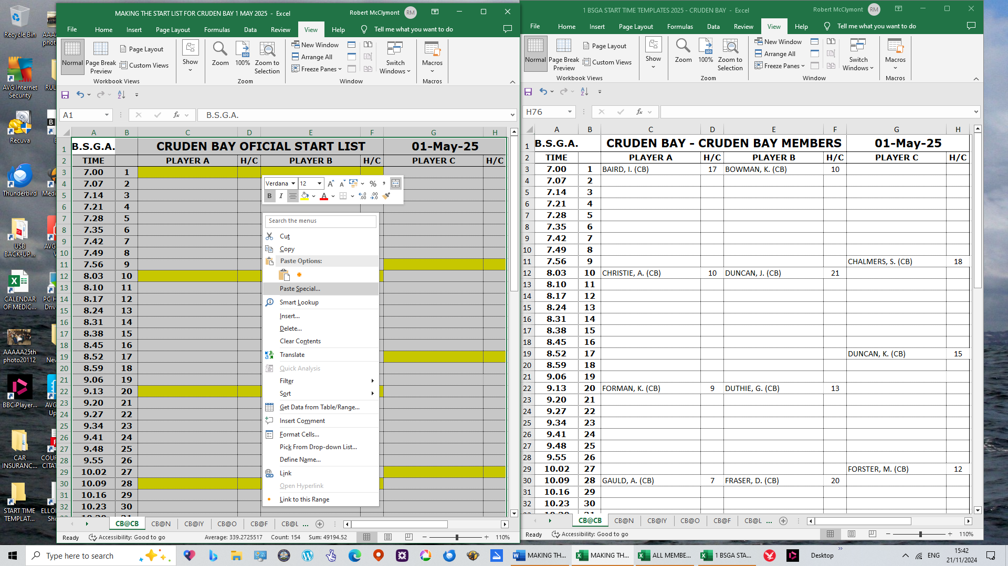

5
THE NEXT DIALOGUE BOX WILL OPEN. AT THE BOTTOM LEFT HAND CORNER OF THAT DIALOGUE BOX, CLICK ON THE SMALL BOX LABELLED “SKIP BLANKS”, THEN CLICK “OK”
.
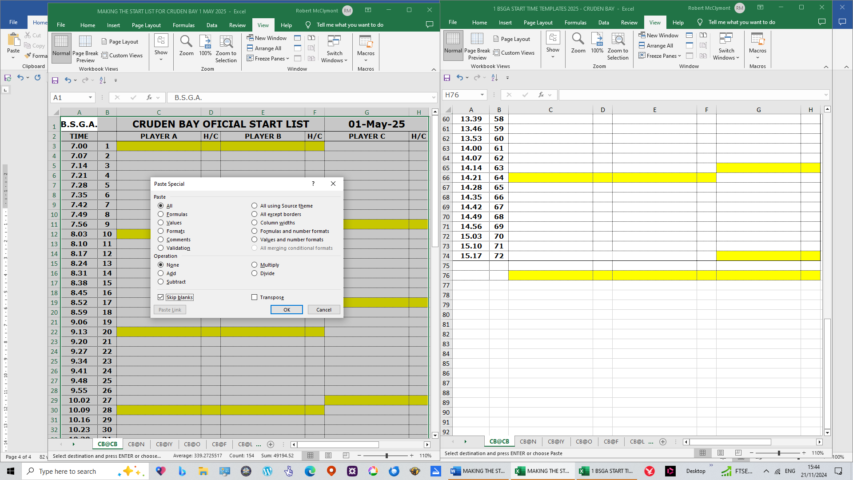

6

THE NAMES FROM CB REP WILL NOW APPEAR IN THE CORRECT TIMES ON THE OFFICIAL START LIST

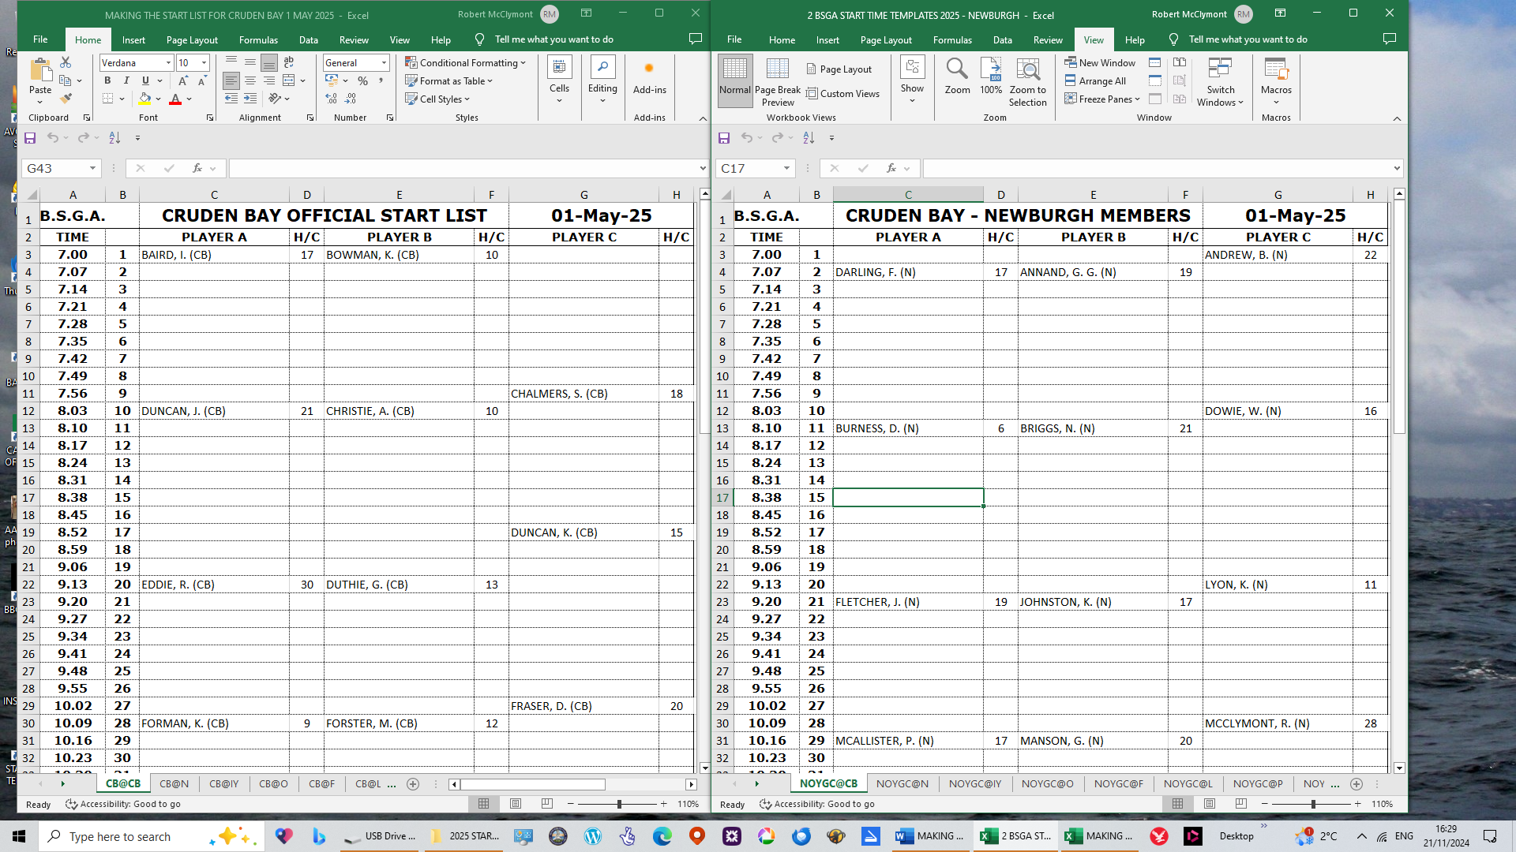

7
THE NEWBURGH REP WILL HAVE SENT MEMBER NAMES ON SELECTED TIMES FOR THE CB OFFICIAL START LIST. REPEAT THE ABOVE PROCEDURES TO ADD THE NEWBURGH NAMES.
REPEAT FOR ALL OTHER CLUBS.

WHEN ALL 9 CLUBS’ NAMES ARE INCLUDED, YOU CAN MOVE MEMBERS UP TO CONSOLIDATE TIMES,
BY A PROCESS OF CUT AND PASTE.

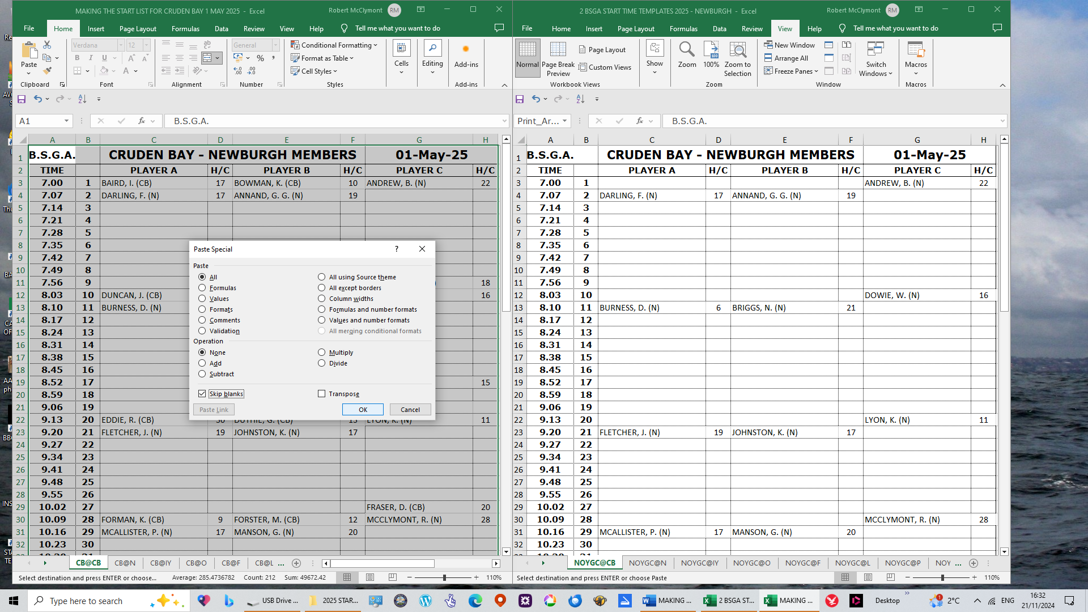

8
YOUR PROCESS OF QUICK VISUAL CHECKS IS USEFUL TO ENSURE THAT THERE ARE NO DOUBLE BOOKED TIMES.

