USING WORDPRESS TO UPDATE THE BSGA WEBSITE

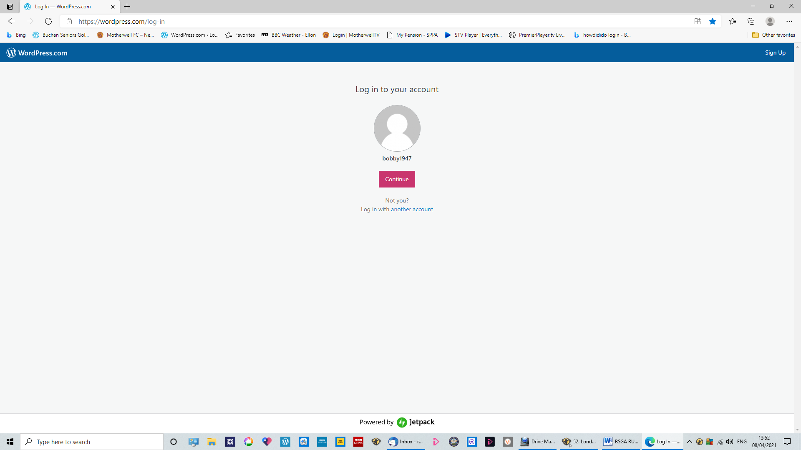
1. Go to your log-in page and enter your password to get into the editor’s page
– or you may have previously have saved your password.
Click on “Continue”.
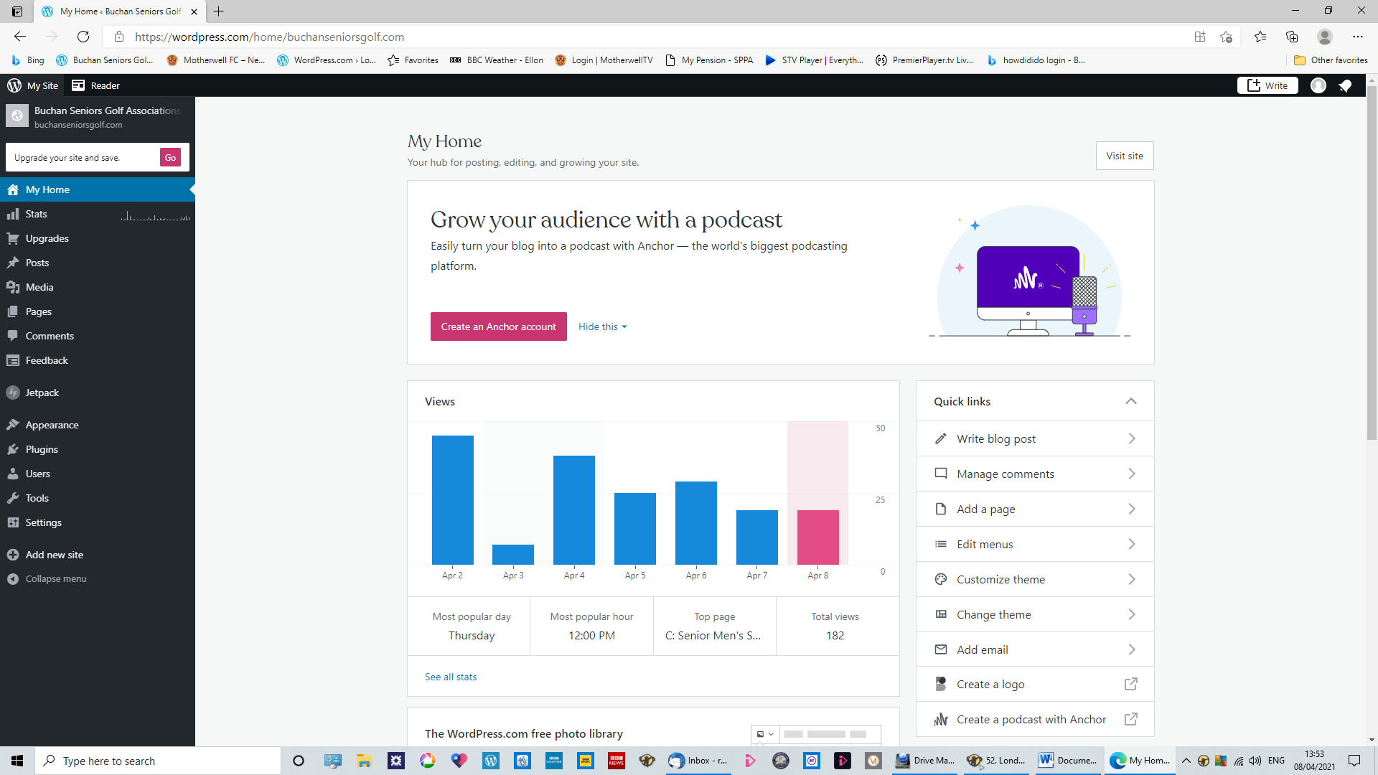
2. Log-in will take you to this page
where you can find access to the pages you wish to edit
on the menu on the left-hand side.
Click on “pages” and a choice will open of “All Pages” & “ Add New”.
Click on “All Pages”

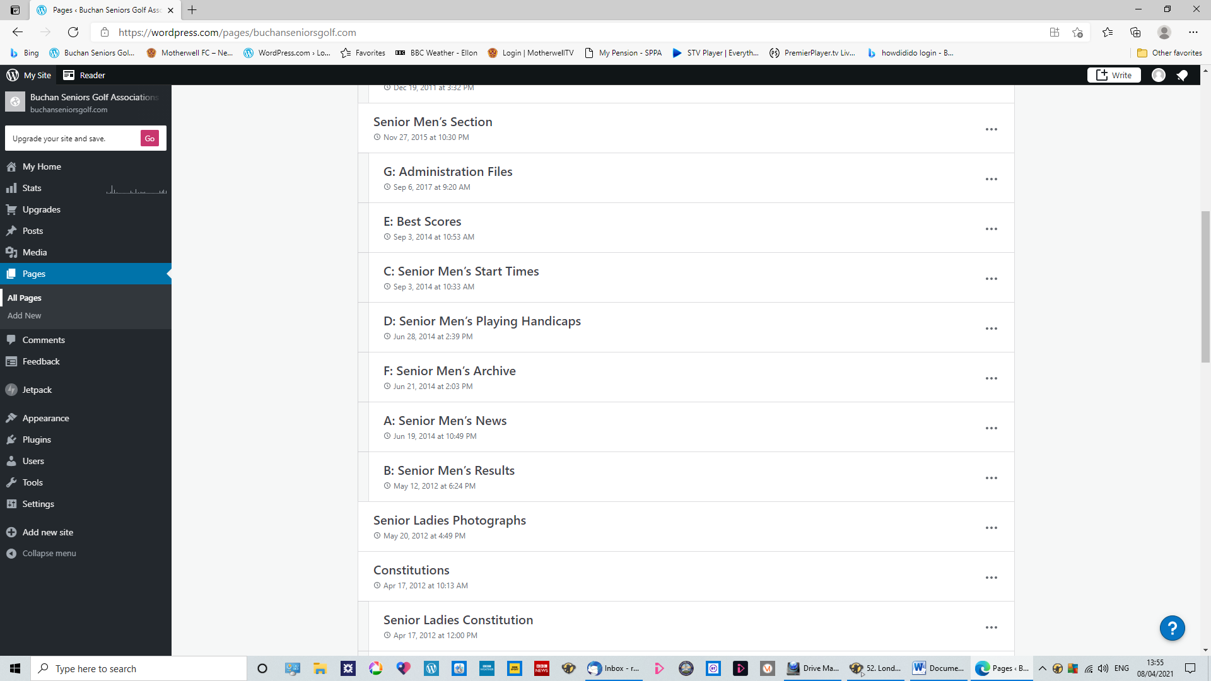
3. Clicking on “All Pages” will take you to this page
which lists all of the pages on the website, starting with the BS Ladies’ pages at the top.
Scroll down until you reach the “Senior Men’s Section”
where the individual pages are grouped together.
Click on ”Senior Men’s Start Times” and it takes you into that page’s editing area.
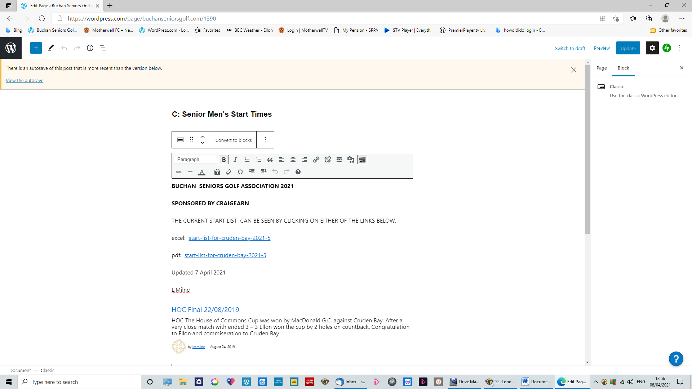
4. In the editing area, place the CURSOR with one click in ANY part of the text.
THINK AHEAD! IF YOU WANT TO IMPORT A DOCUMENT LINK TO THE MEDIA LIBRARY IN THIS PAGE,
PLACE THE CURSOR AT THE VERY POINT WHERE YOU WANT THAT LINK TO APPEAR!
IN THIS CASE JUST TO THE RIGHT OF “EXCEL:”!
REMOVE THE EXISTING LINK IF THERE IS ONE.
When you place the cursor in the text, the TASKBAR will appear below the title of the page.
Click on the top row of symbols in the Taskbar, on the second logo from the right
which has a little “Music” symbol.
That will take you to the MEDIA LIBRARY where photos and documents are stored on the site.

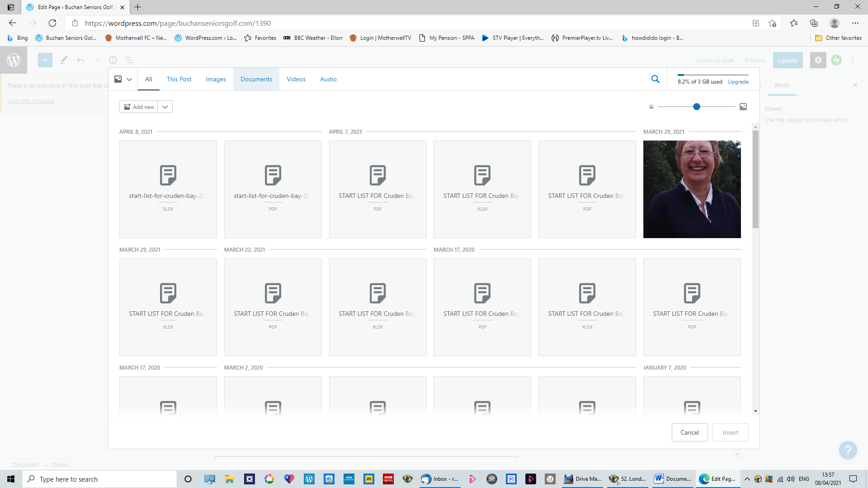

5. You have now entered the “Media Library”.
Each item of media appears in a box.
If you click on “Documents” on the top bar, only the documents will appear.
If you want “Images”, click on that and only photos will appear.

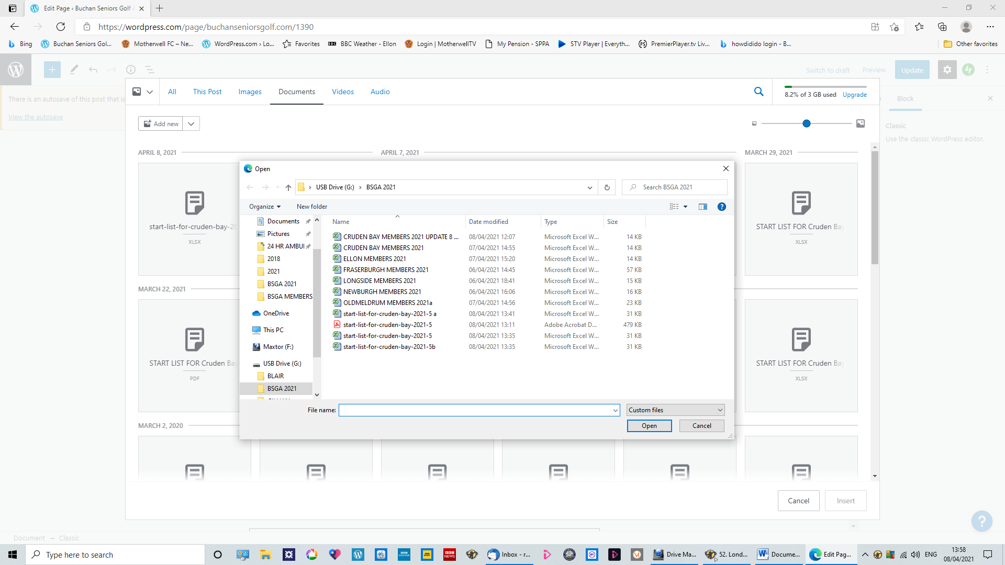

6. To add new documents or photos to the Library, on the top left click on “Add New”.
That will open up access to your PC/laptop’s files which you can select by highlighting (double-click),
which will take the selected item into the library where the latest addition will always appear as top left.

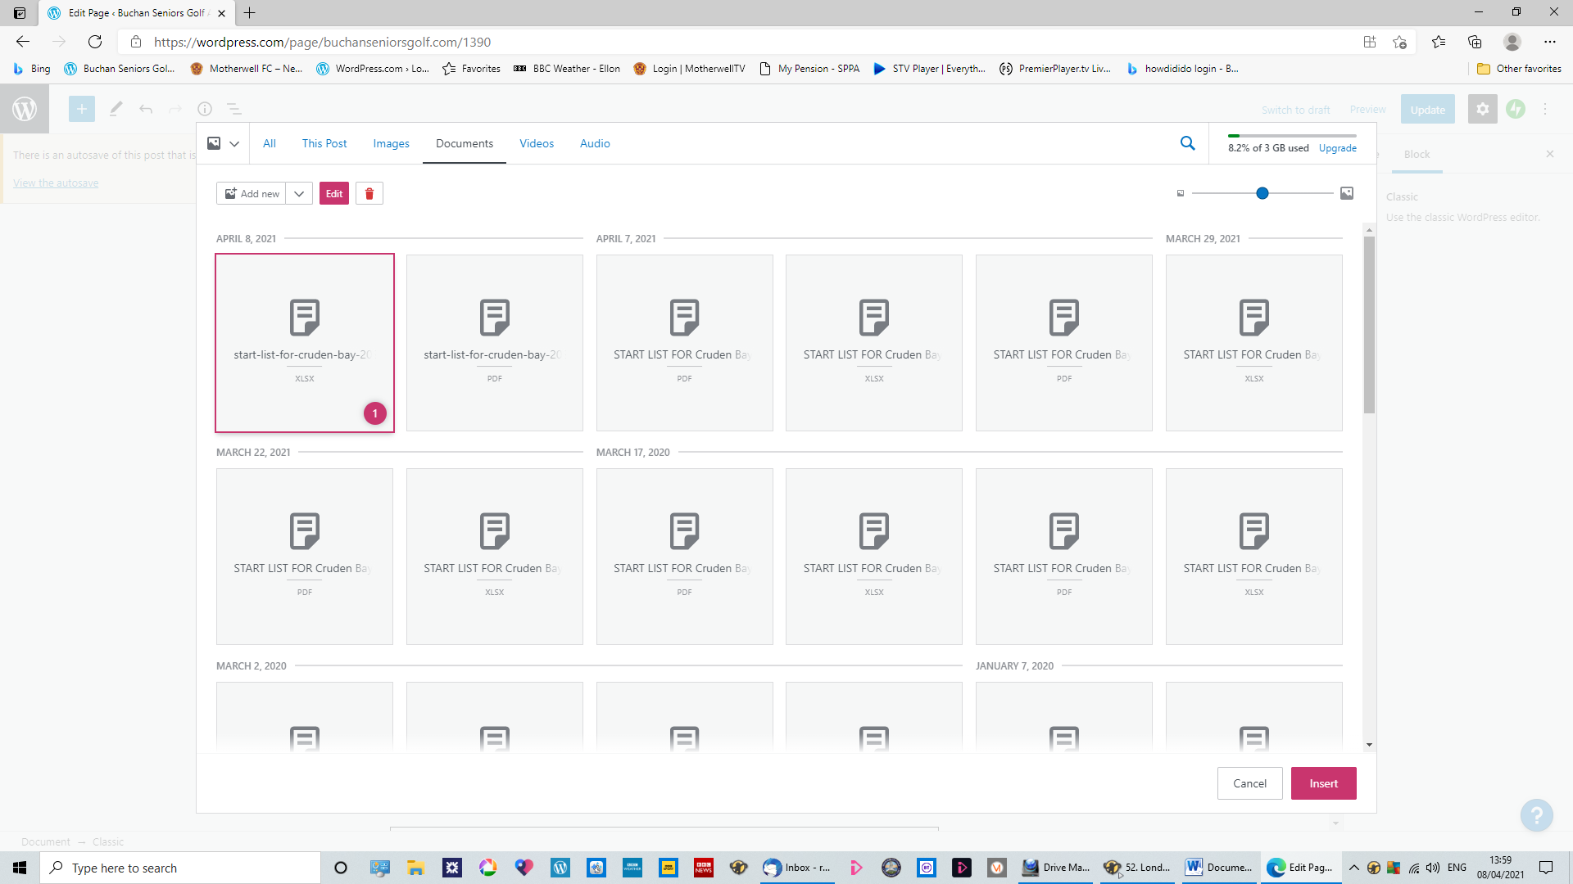

7. Click on the document you want to upload to highlight it in red border.
When you do that, a small red box will appear bottom right with “INSERT” printed in it.
Click on “INSERT” and your document title in link format will appear in the page you are editing
AT THE EXACT POINT WHERE YOU LEFT THE CURSOR”!!

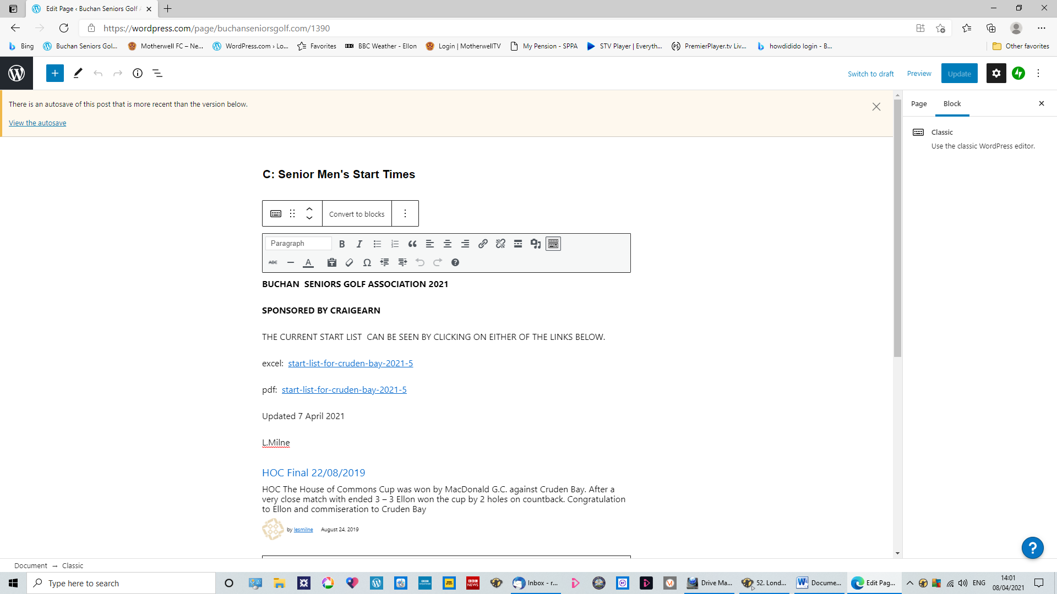
8. When you click on “INSERT” you will be taken back to the page you are editing
and you will see your link at the POINT EXACTLY WHERE YOU LEFT THE CURSOR.
YOU HAVE NOT CHANGED ANYTHING ON THE PAGE AT THIS STAGE!!!
If you are happy that everything is as you want it on the page, including a second document in this case,
YOU MUST NOW GO TO THE BLUE SQUARE IN THE TOP RIGHT AND CLICK “UPDATE”.
YOU HAVE NOW CHANGED THE PAGE.!!!
And you can click on “Preview”(Next to “update”)
to see how the page will look on the website page when members access it.

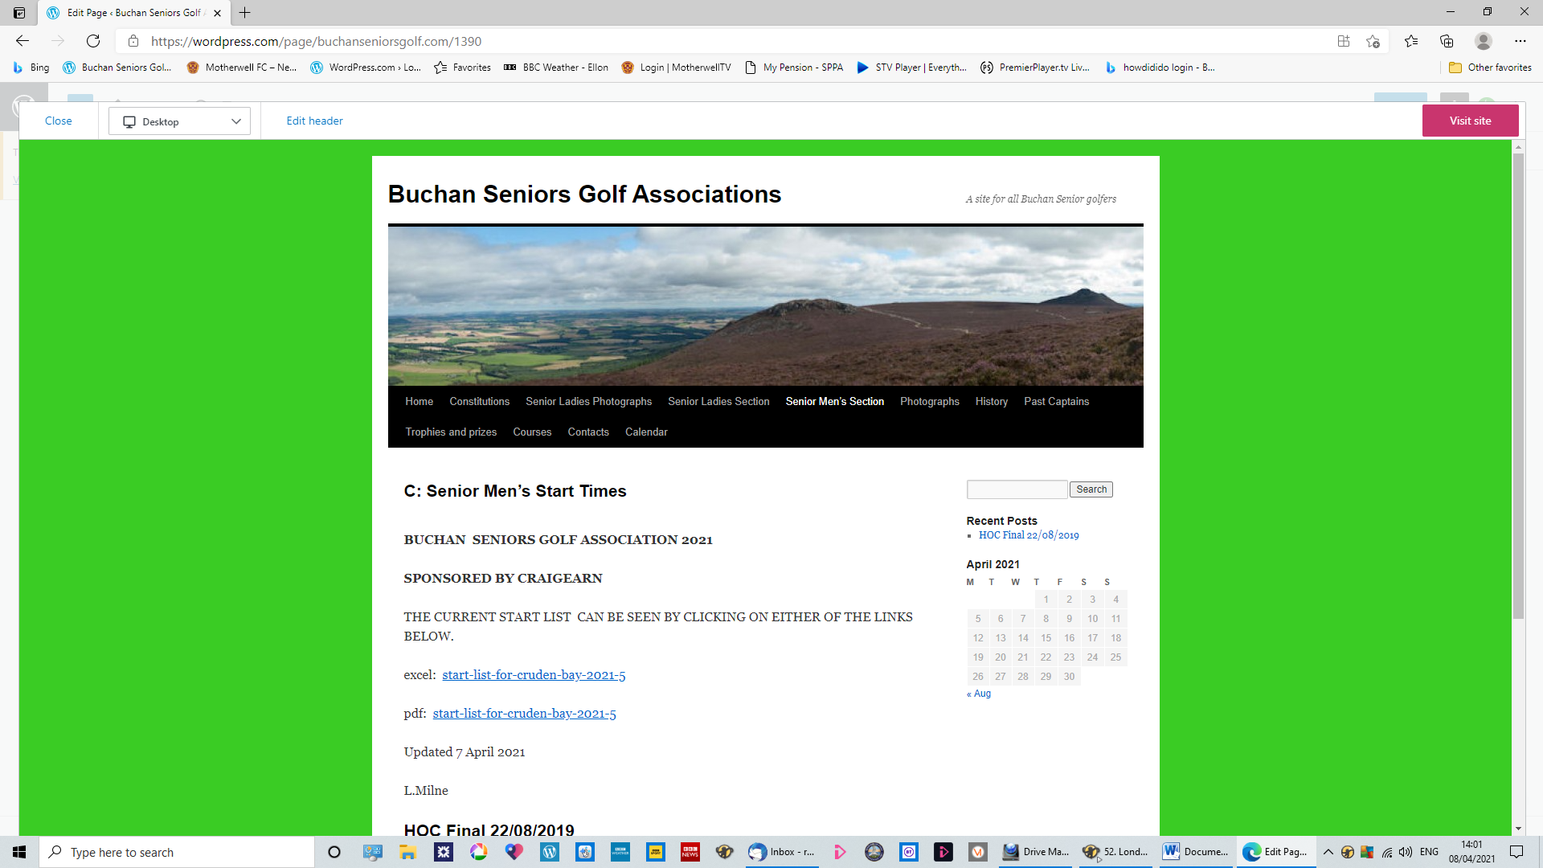
9. This is what you will see when you click on “Preview” – the page you have edited.
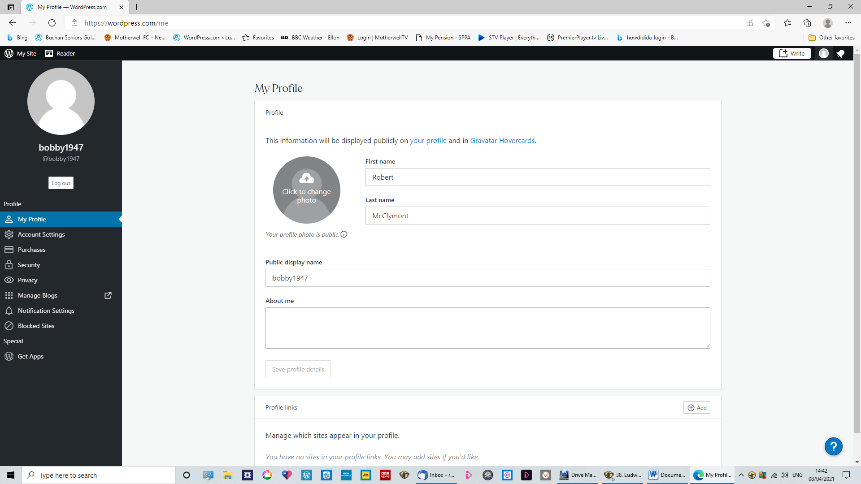
10. If you are happy with how it looks you can select another page to update
(to do this, go back to page 2 of this guide) or you can log-out.
Click “Close” in the top left to go back to the editing page.
To log-out, go to the top right and click on the little person logo and the “My Profile” page will appear.
On the far left of that is the black menu again and above it the white button to log-out.

R.McClymont 8 April 2021

