HANDICAPMASTER COMPETITIONS DAY SET-UP
Setting up scores PLAYER ENTRY

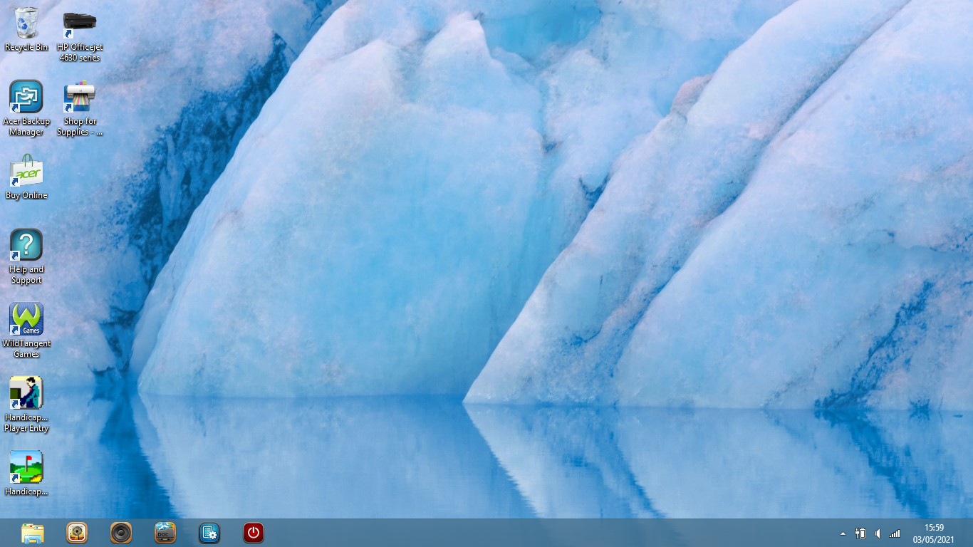
- LOGIN TO THE LAPTOP and on the desktop page click on the HandicapMaster icon at bottom left.

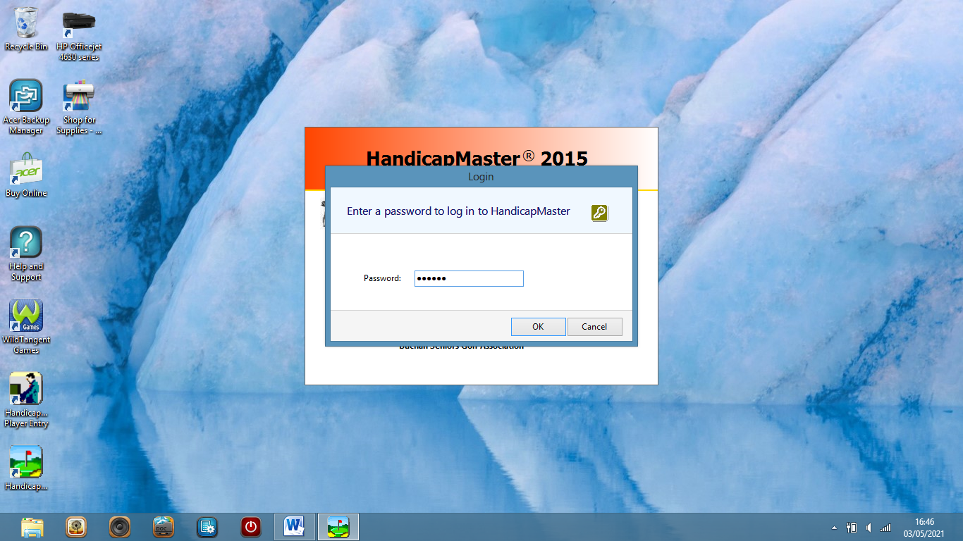
- Enter the password “********” and go to the main menu page.

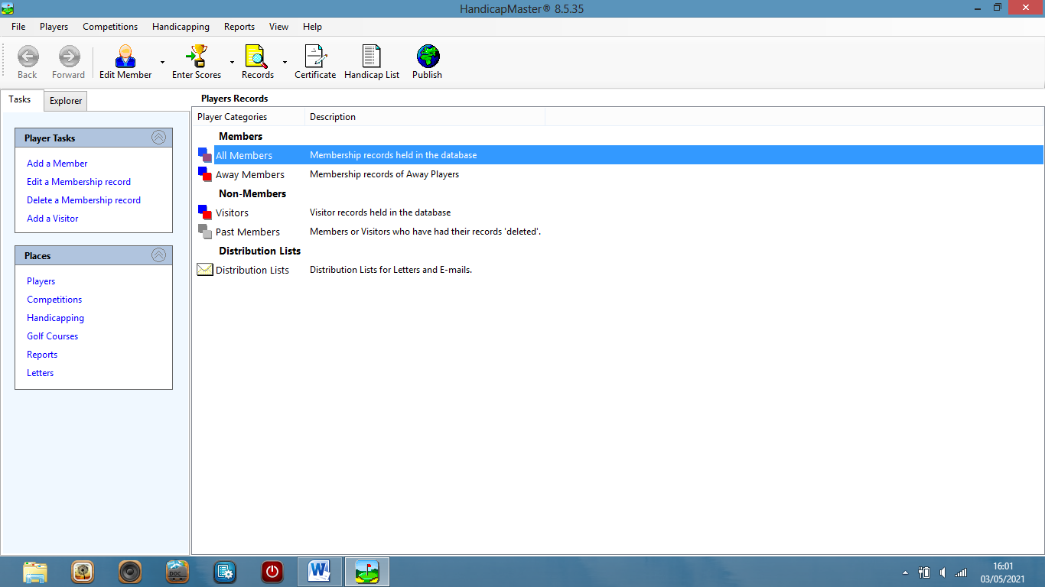
- On the main menu page, click on “Competitions” on the “Places” Menu on the left.

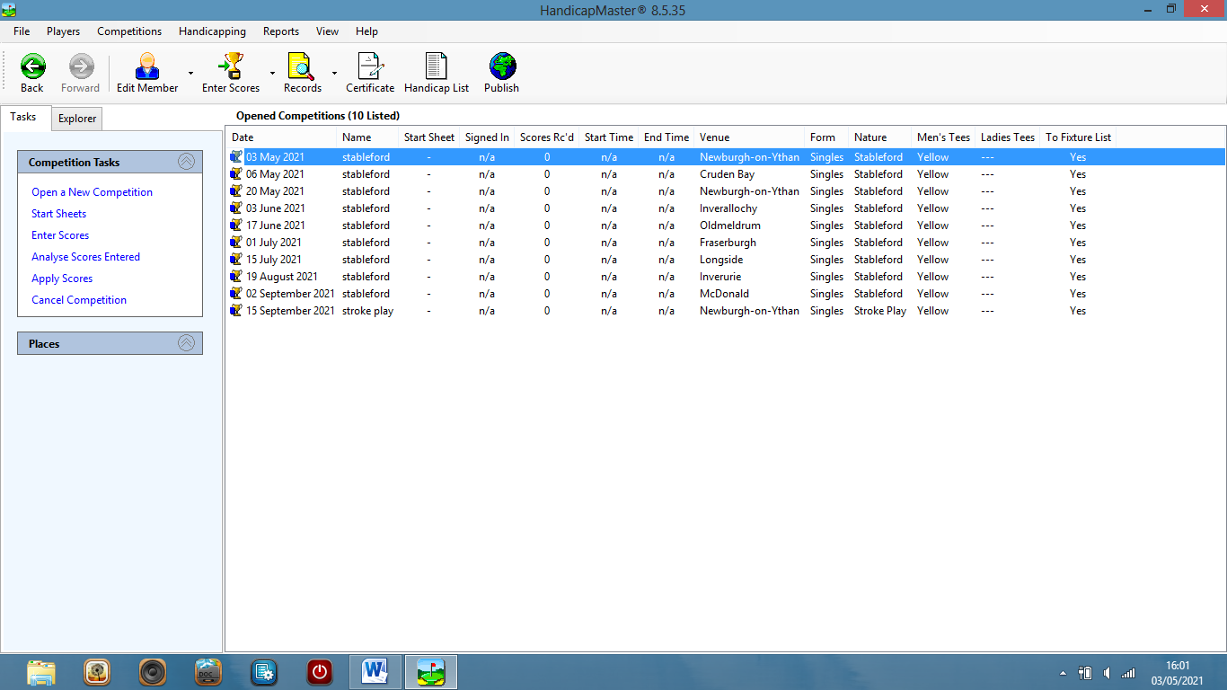
- Click on the competition of the day on the list of competitions.

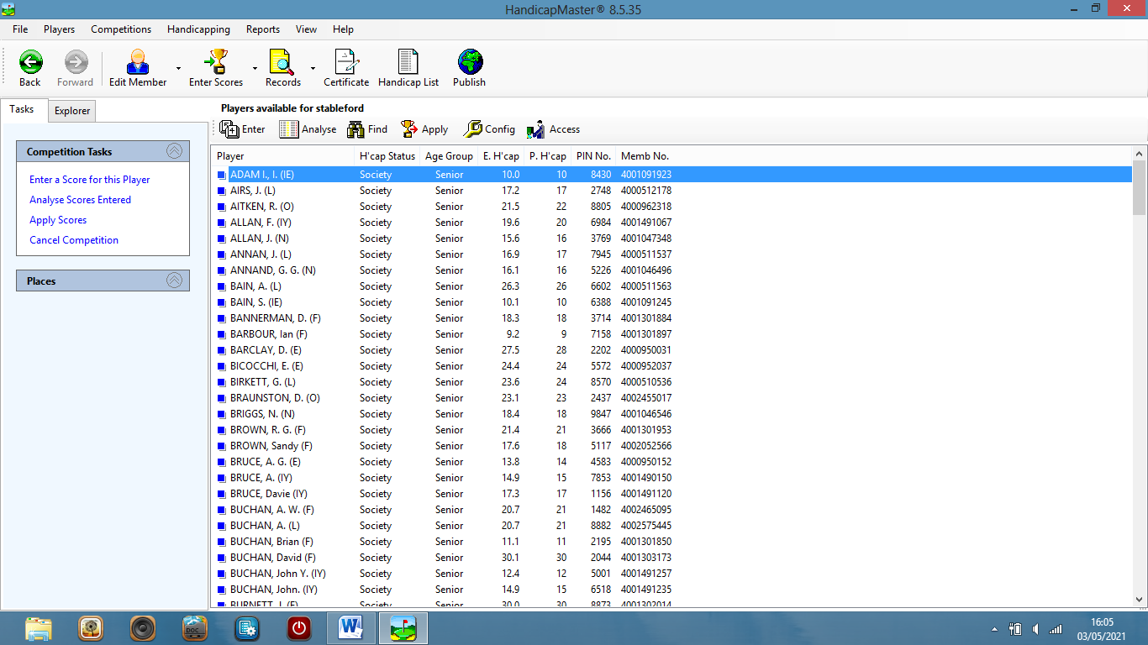
- The members list will appear in alphabetical order.
YOUR FIRST TASK IS TO CHECK THE HOME CLUB SCORECARD AGAINST THAT STORED ON THE COMPETITION TEMPLATE.

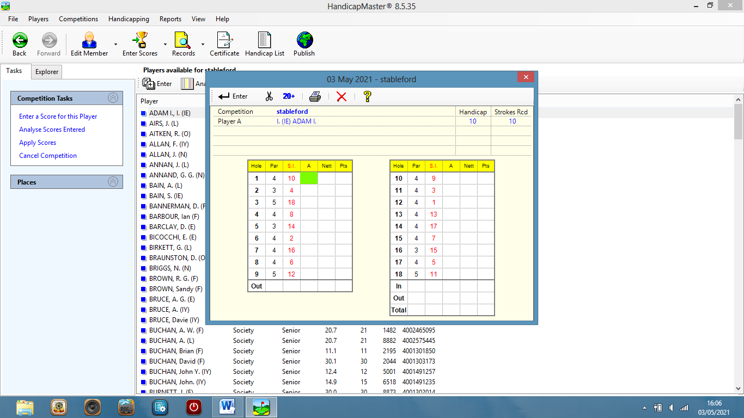
- Click on the first member’s name and his scorecard will appear.
FOR EACH OF THE 18 HOLES, CHECK THAT THE ON-SCREEN SCORECARD HAS THE SAME PAR AND STROKE INDEX FIGURE FOR EACH HOLE AS THE CLUB SCORECARD BEING USED BY MEMBERS ON THE COURSE TODAY.

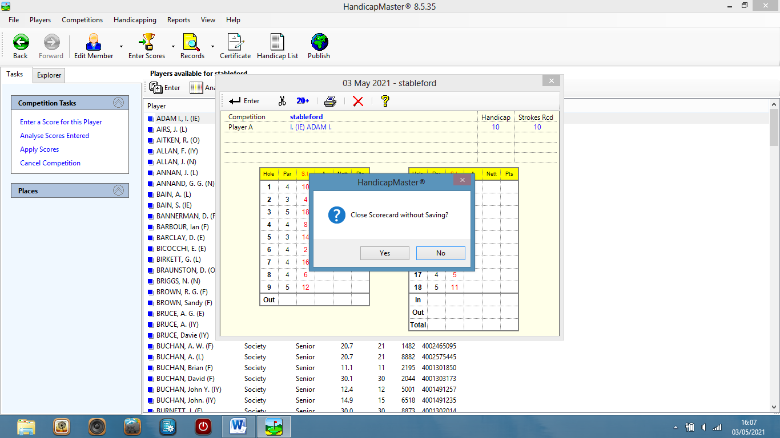
- If the check is good, close the scorecard without saving any score.

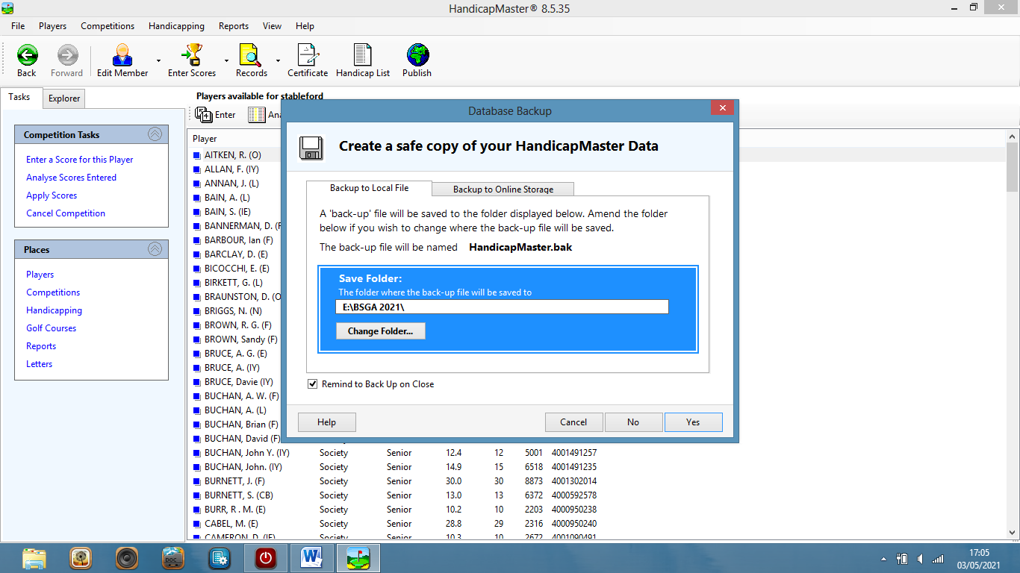
- Exit HandicapMaster, clicking “Yes” to a back-up request if you have a pen-drive in the socket .
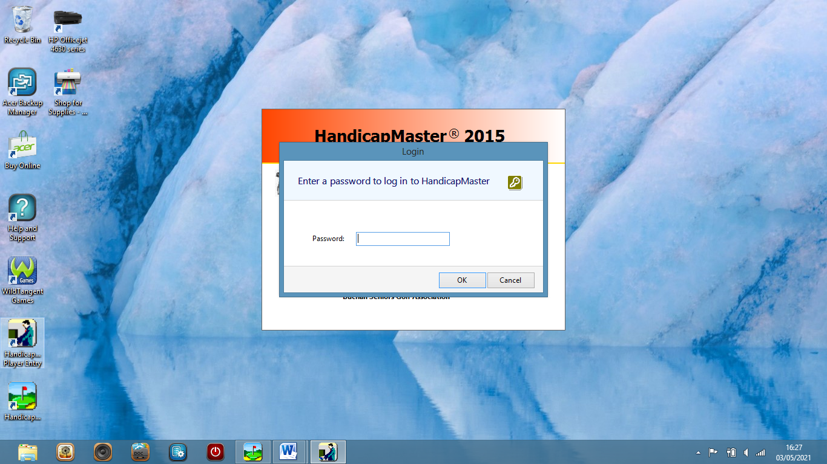
- Back to the desktop menu, CLICK ON THE ICON “HANDICAPMASTER PLAYER ENTRY” ON BOTTOM LEFT, ABOVE THE MAIN HANDICAPMASTER ICON.
YOU WILL NEED TO ENTER THE PASSWORD “*******”.
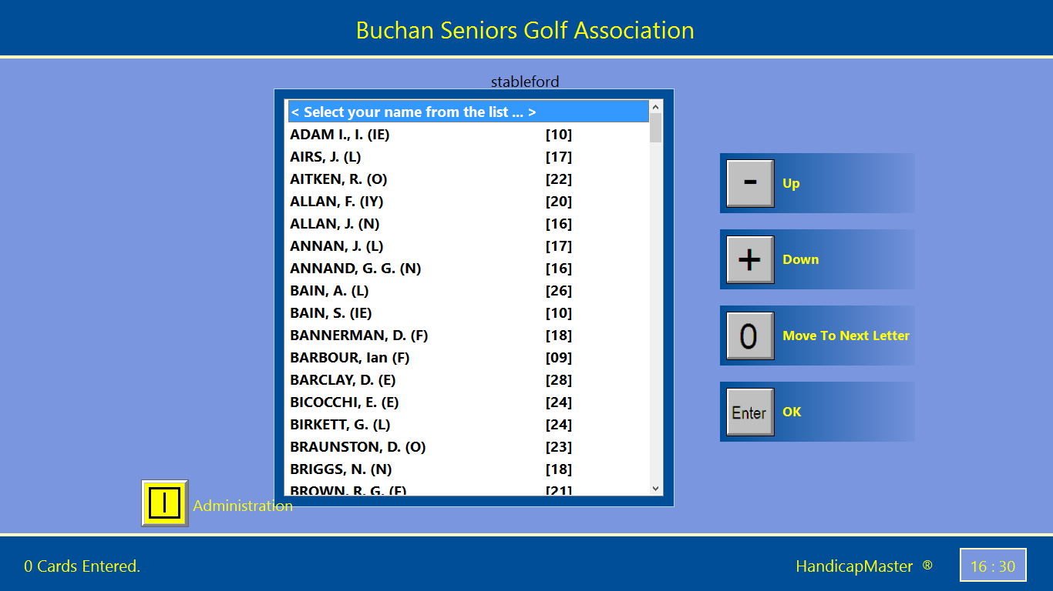
10.You will now enter the members list for score entry,
WHERE MEMBERS CAN SELECT THEIR OWN NAME BY
NAVIGATING UP OR DOWN THE MENU AND STOPPING ON A NAME BY PRESSING “ENTER”.
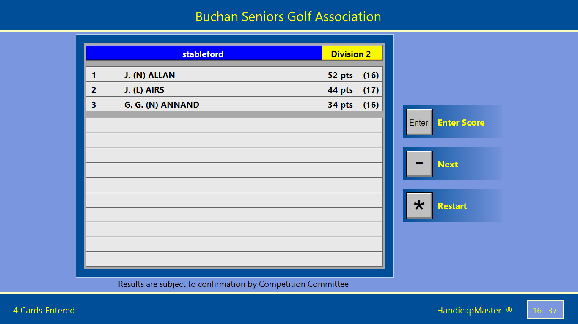
11.At times when no scores are being entered, the members list will disappear and ENTERED SCORES WILL APPEAR ON SCREEN SCROLLING DOWN FROM THE TOP OF DIVISION 1 through each of the divisions.
WHEN THIS SCROLLING IS PROCEEDING, A CLICK ON ”Enter” WILL RETURN THE SCREEN TO THE MEMBERS LIST WHICH WILL ALSO DISPLAY THE YELLOW BUTTON LABELLED “administration”.
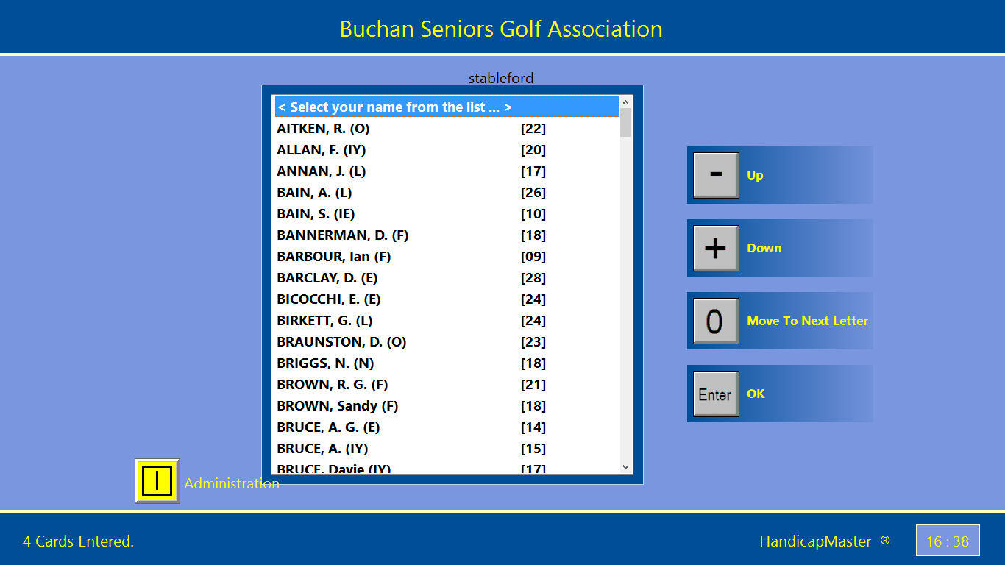
12.Clicking on the “Administration” button will take you out of “PLAYER ENTRY” and allow the completion of other tasks in HandicapMaster from the Desktop page.

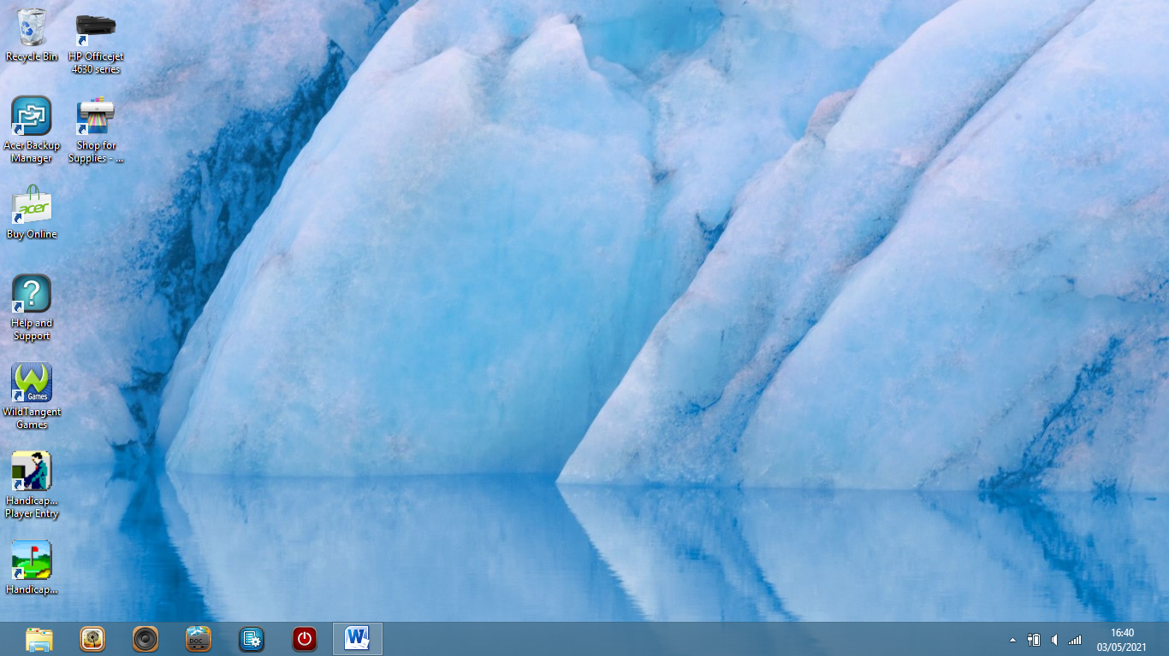

DESKTOP PAGE

