HANDICAPMASTER 2015: HOW TO USE FOR BUCHAN SENIORS COMPETITIONS
POWER-UP THE LAPTOP AND OPEN IT WITH THE PASSWORD “********”
LOGIN
This Laptop and program is the BSGA Database of current members and past records, going back to 2012. On the start page, click on the HandicapMaster icon, bottom left.
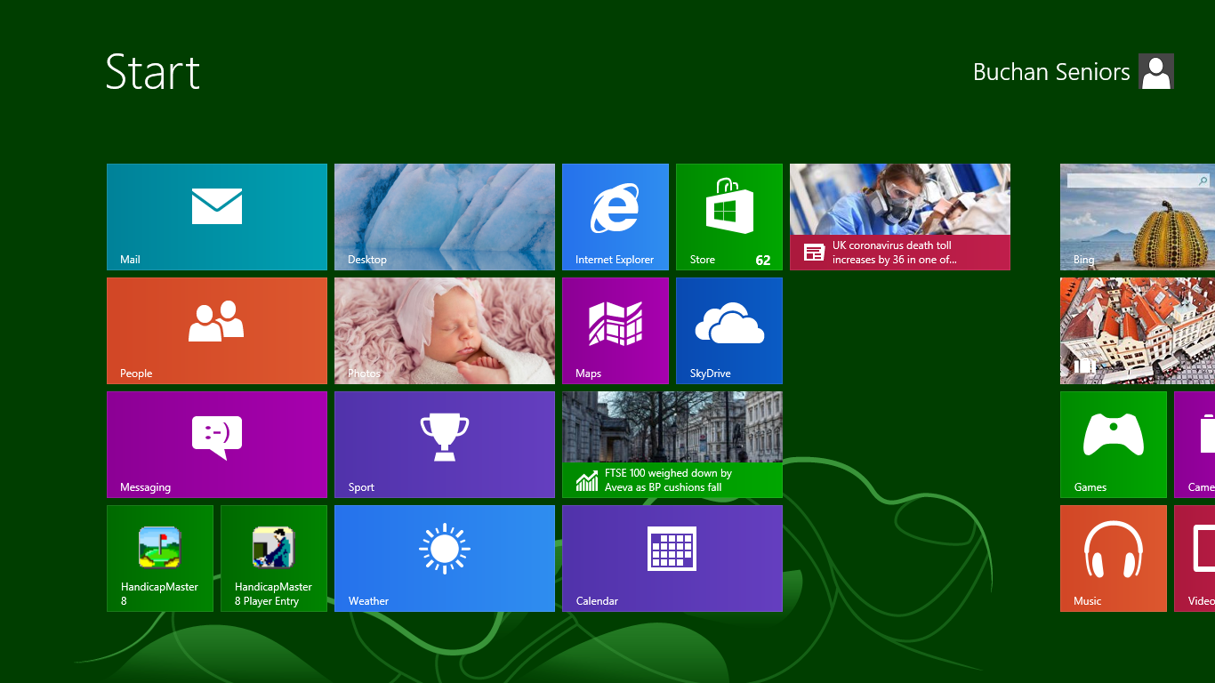 This software package, HANDICAPMASTER 2015, is the BSGA DATABASE.

ENROLLING MEMBERS AND PUTTING THEIR DETAILS ON RECORD

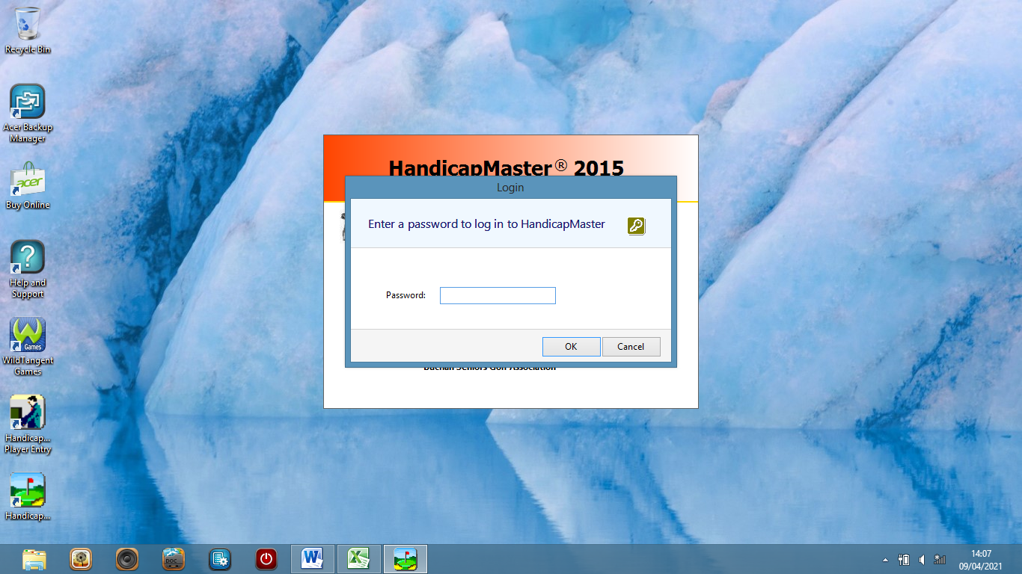
1. This program is the BSGA Database of current members and past records, going back to 2012.
On the first page you can log-in with the password “*********”.
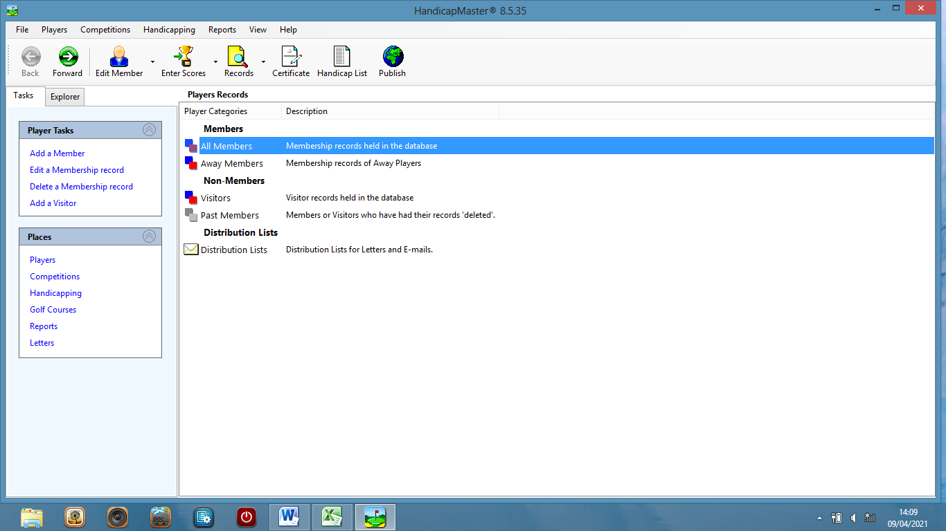
2. Your log-in will take you to this page from which you can navigate to all possible player data management options.
There are entries only in “All Members” and in “Past Members”.
Click on the top line of choices “Membership records held in the database”.
This shows the current BSGA Membership.
The top menu on the left hand side of the page “Player Tasks” takes you into the members list
and allows you to add, edit, delete and undelete player records.
Records deleted will remain in the “Past Members” list.
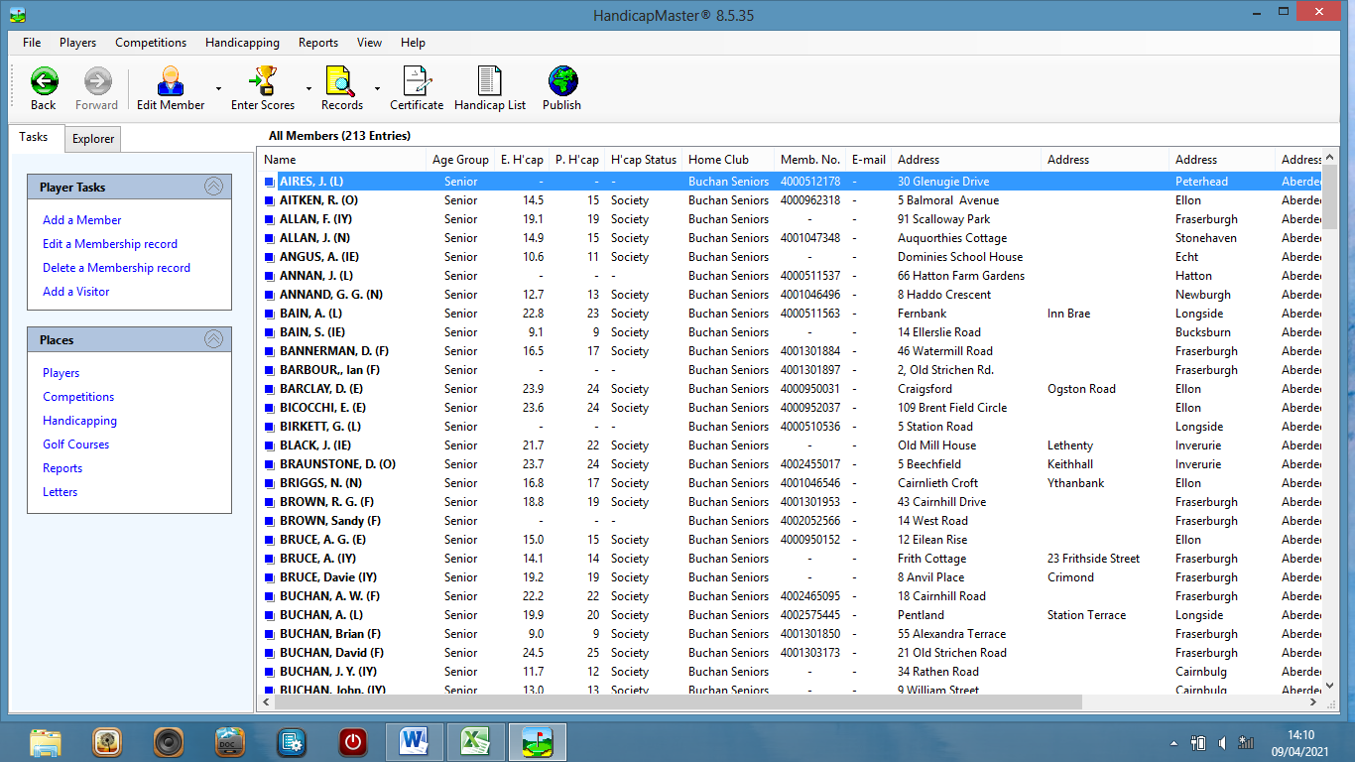
3. One click on a name will highlight the full member record. It includes surname, first name initial and club initial in brackets.
This is how each player is named on results lists. As a “Society” record, handicap and club information refers only to BSGA events.
Also included for all players is an address and phone number.
The phone number’s most likely use is in contacting home in the event of an accident
– a circumstance in which a mobile number can be of little use!
Under “Member No.” each player’s CDH number is shown.

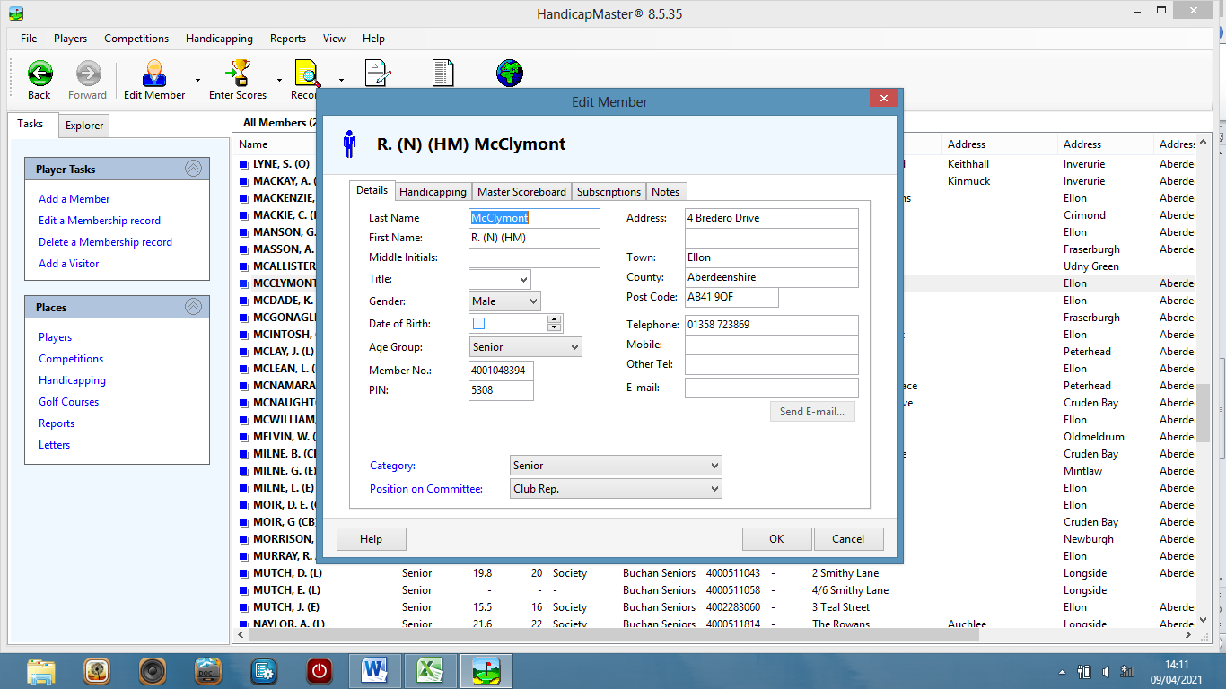
4. A click on a name highlights the name, another click opens up the member record editing panel.
Data on the record can be changed manually by clicking on individual boxes or by copy and paste and/or cut procedures.
All members are classed as “Seniors” in each of the status boxes.
The “PIN” is randomly issued by the software but is unused by BSGA.
This box shows all of the personal information kept for the member.

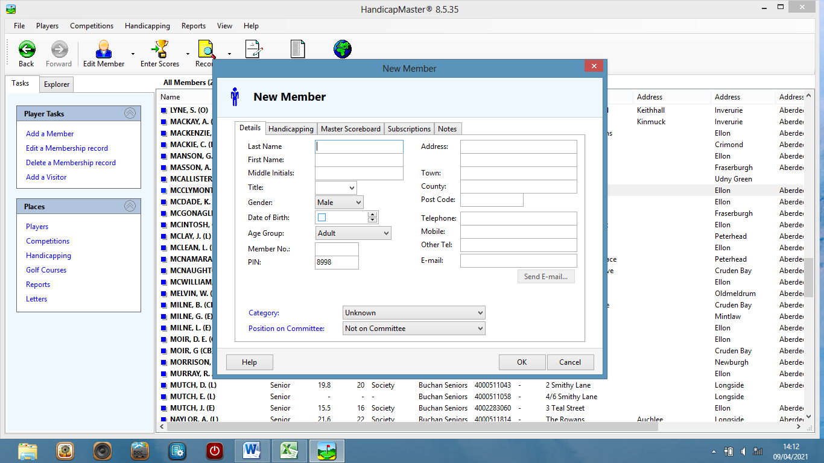
5. New members can be added to the membership by clicking on the “Add a Member”
at the top of the “Players Tasks” menu.
By entering the member details and clicking on “OK”,
the player is added to the record of Members.
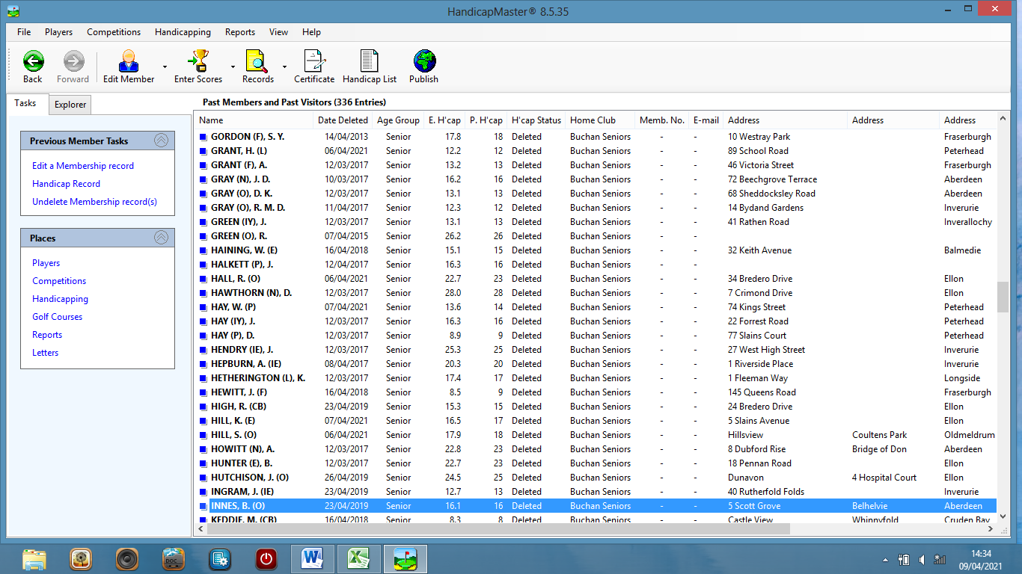
6. It is not uncommon for a member to re-join after a season or more as a past member.
Such players can be “Undeleted” and restored to the Members List by Clicking in the “Previous Members Tasks”
on the “Undelete” option and on a subsequent page clicking on the individual player’s details.
Always check that data has not changed in the meantime (address, phone no. etc.).

R.McClymont May 2021

