HANDICAPMASTER : CLOSING A COMPETITION MAY 2021
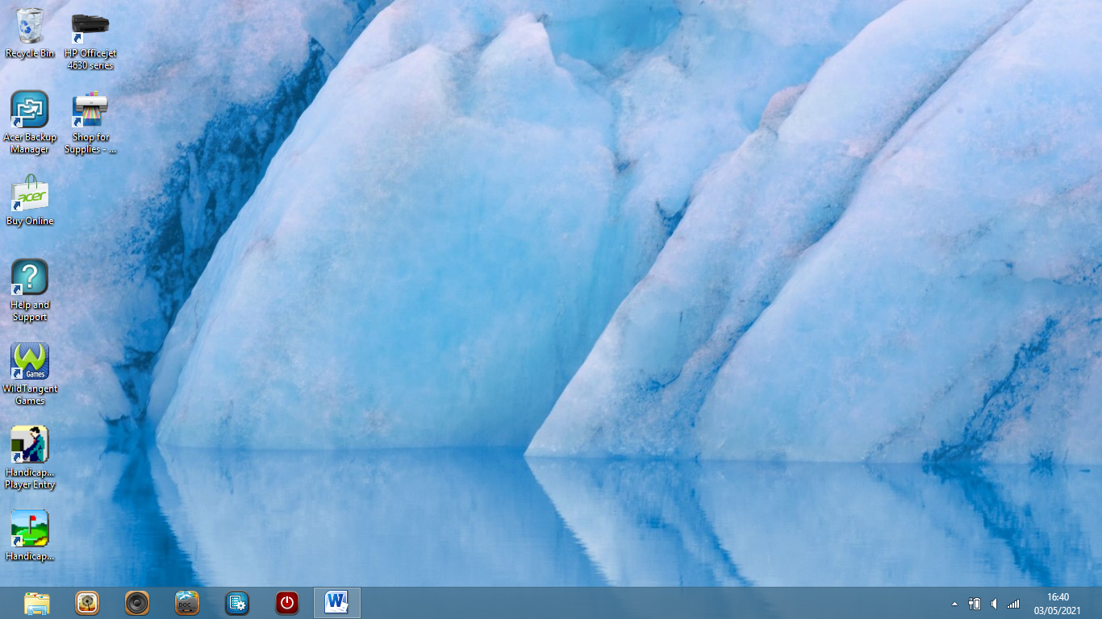
- Enter HandicapMaster by the password “*******” from the DESKTOP page.

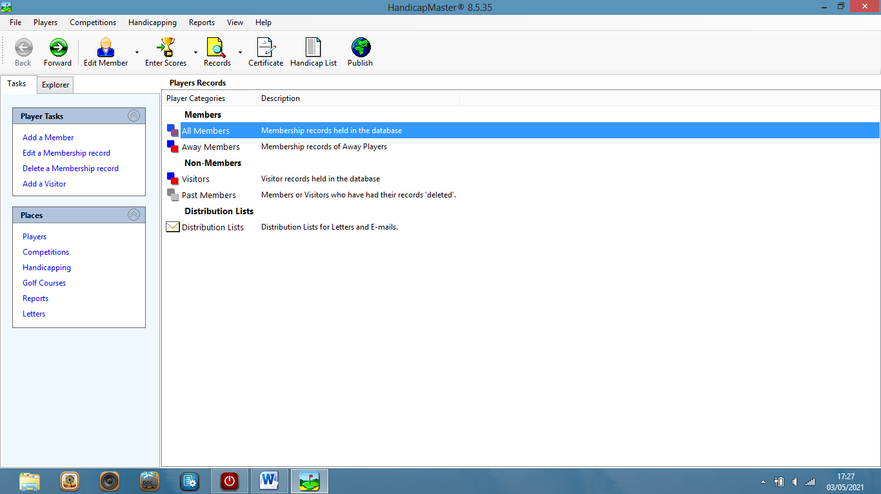
- On the Main Menu page, click on “Competitions” on the lower left hand menu.
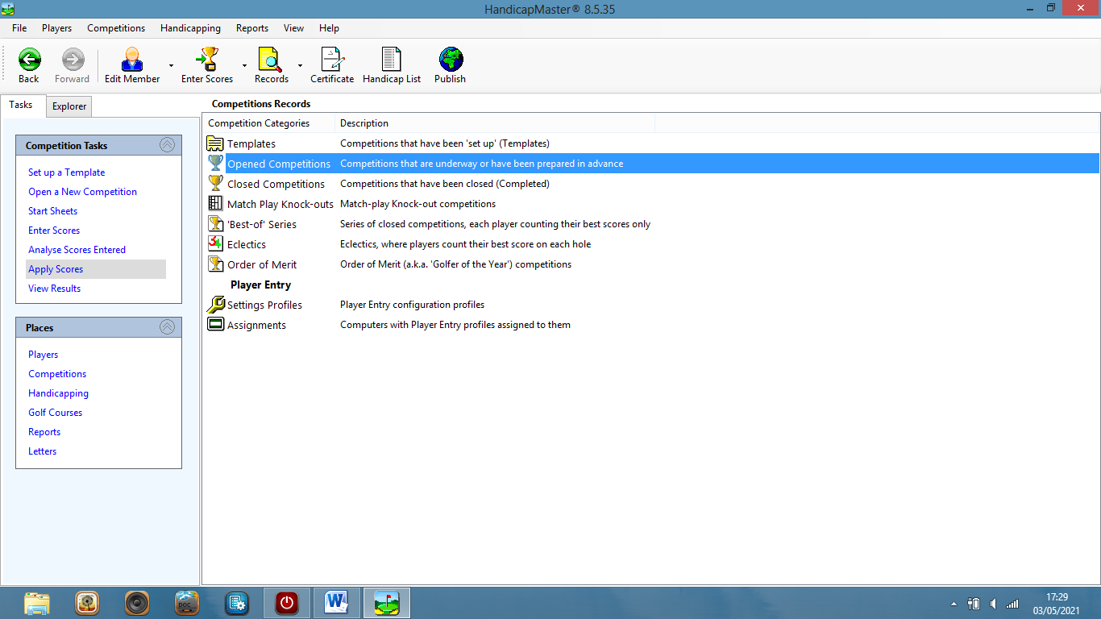
- On the “Competition Tasks” menu – now upper left – click on “APPLY SCORES”.
This is the procedure which leads to the closing of the day’s competition.
DO NOT START THIS UNTIL YOU HAVE GATHERED TOGETHER THE CARDS OF THE TOP FIVE MEMBERS IN EACH DIVISION.
THES CARDS SHOULD ALSO BE CHECKED AGAINST SCORE ENTRIES TO CHECK THAT THE ENTRIES ARE ACCURATE.

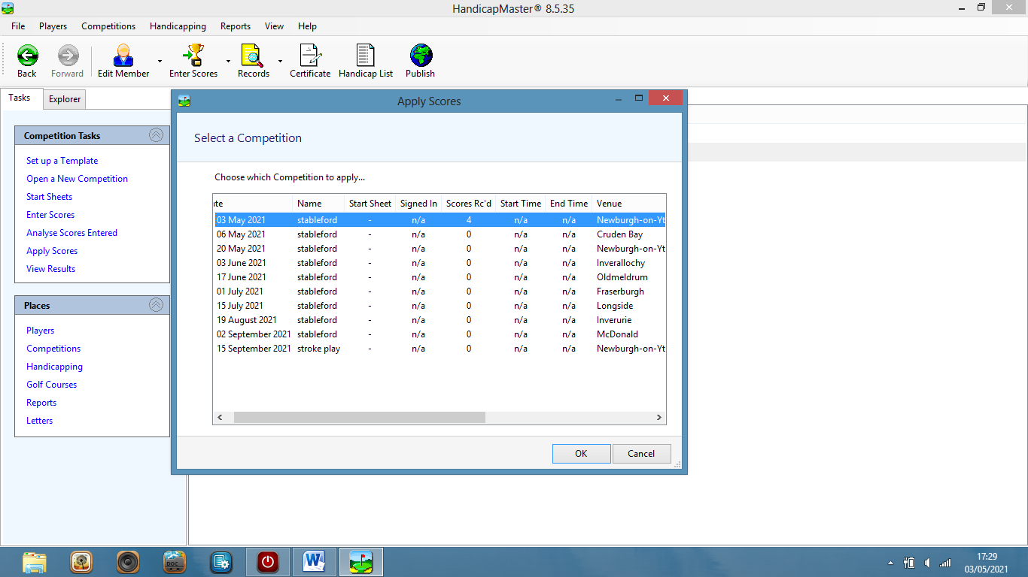
- Clicking on “APPLY SCORES” will take you to the list of competitions on which the current day’s competition will be highlighted.
On that “SELECT A COMPETITION” dialogue box click “OK”.
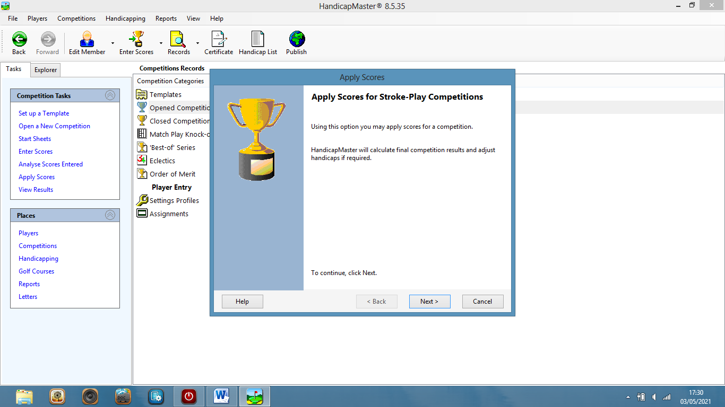
- The next page shows the dialogue box “APPLY SCORES FOR STROKEPLAY COMPETITIONS”. THIS INCLUDES STABLEFORDS!
Click on “NEXT”.
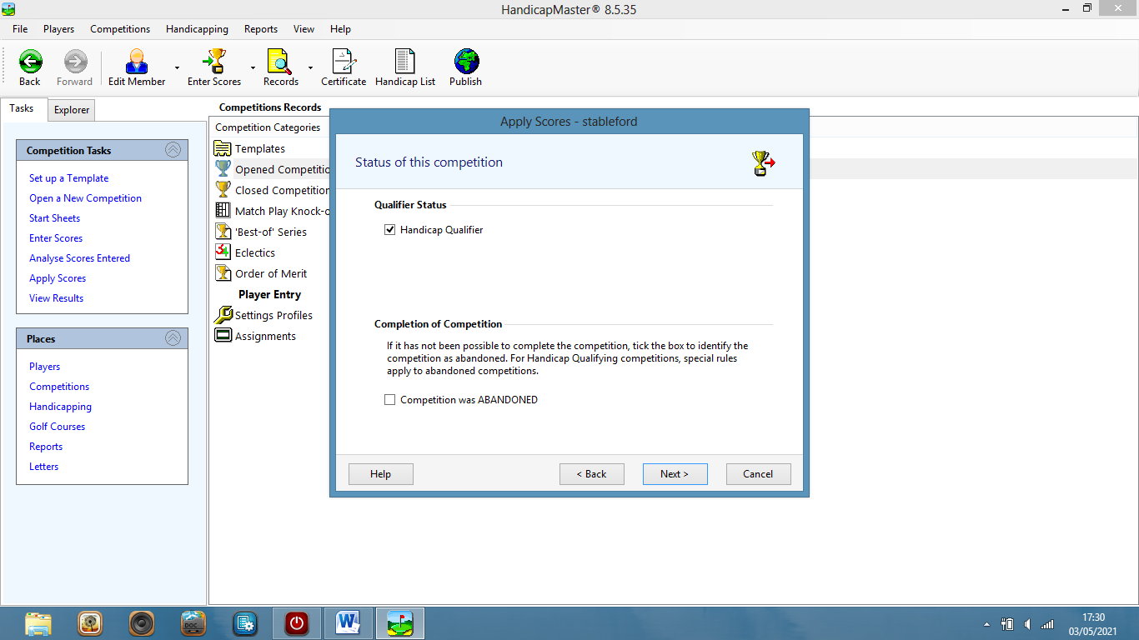
- The next page is called “STATUS OF THIS COMPETITION”. If the competition has been concluded satisfactorily, click on “NEXT”.
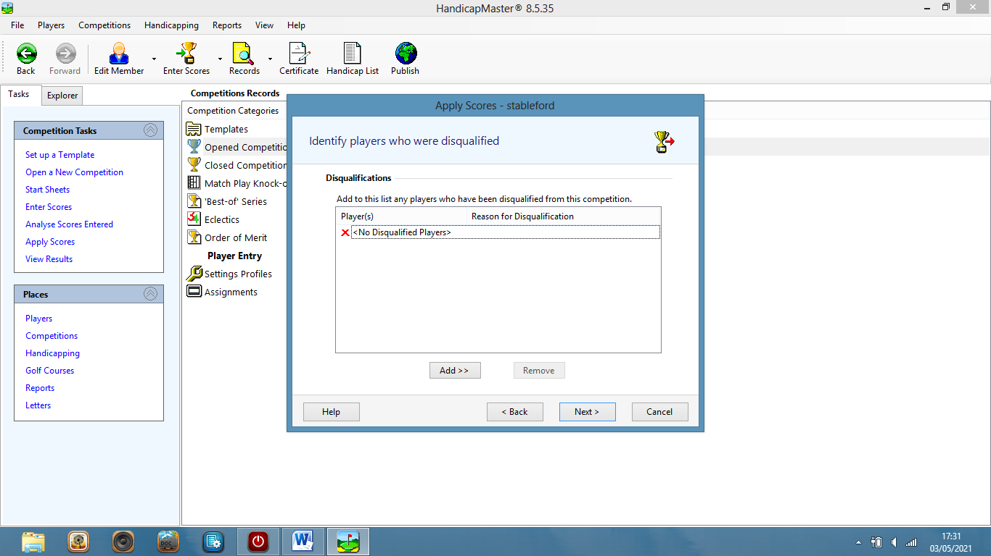
- The next page is called “IDENTIFY PLAYERS WHO HAVE BEEN DISQUALIFIED”.
Disqualifications are most likely to have been decided in the score checking procedures on scorecards and entered scores.
IF THERE ARE NO DISQUALIFICATIONS, CLICK ON “NEXT”.
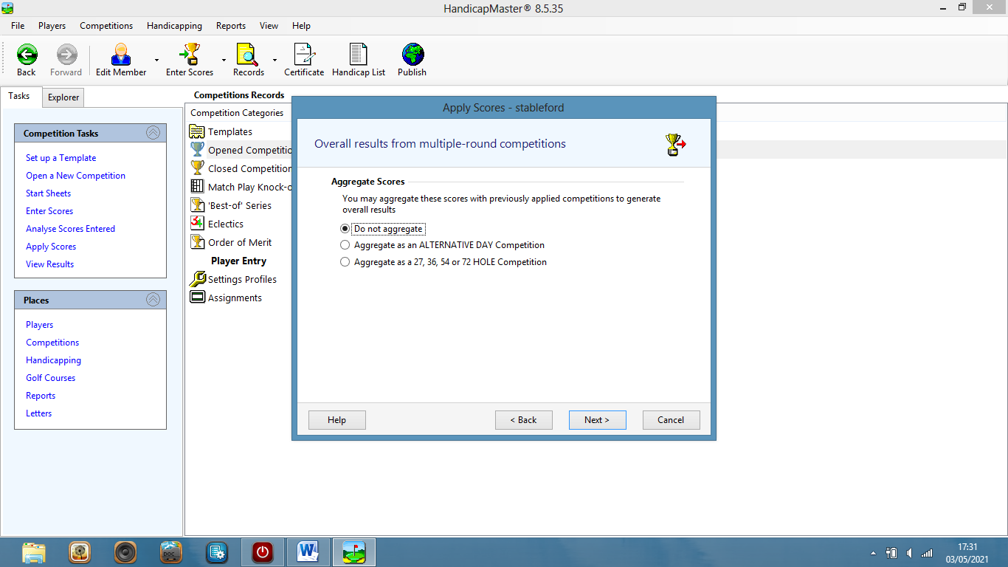
- AS THERE ARE NO MULTIPLE ROUNDS IN BSGA , CLICK “NEXT”

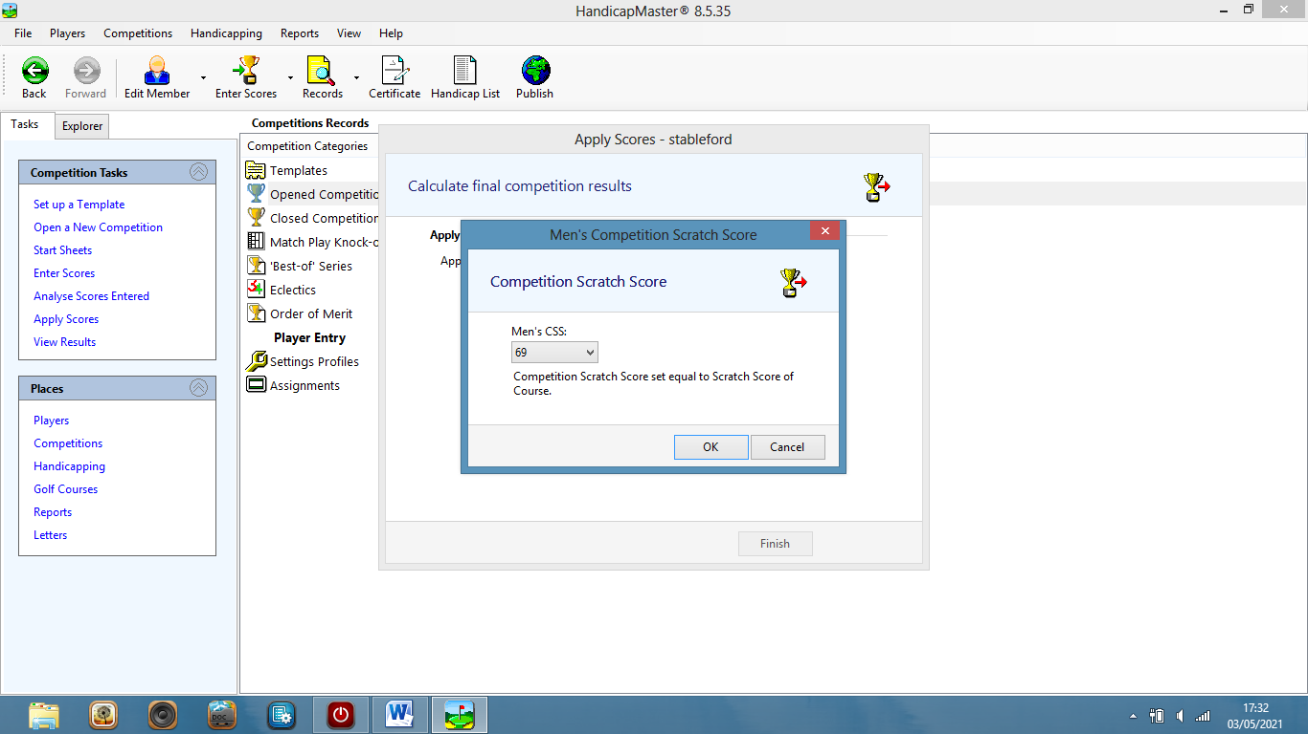
- THE COMPETITION CSS IS SHOWN ON THIS PAGE AS SUCCESSFULLY CALCULATED. CLICK ON “OK”.
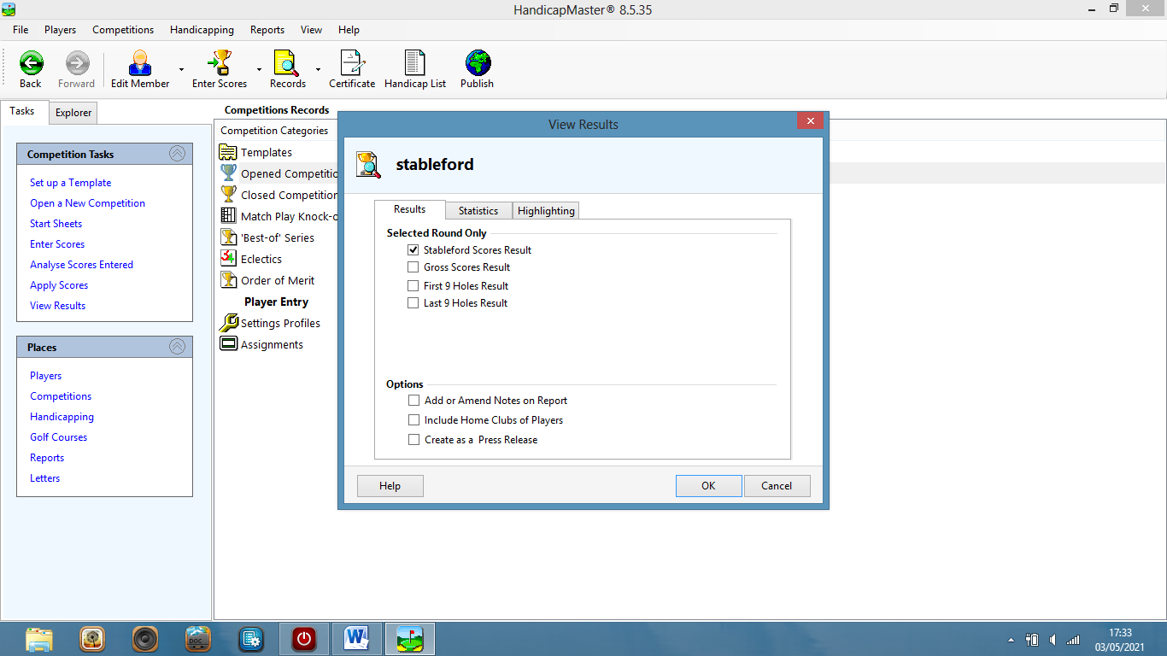
10.On the page “STABLEFORD” make sure the top line in the dialogue box is ticked to request “STABLEFORD SCORES RESULT”. Click on “OK”.
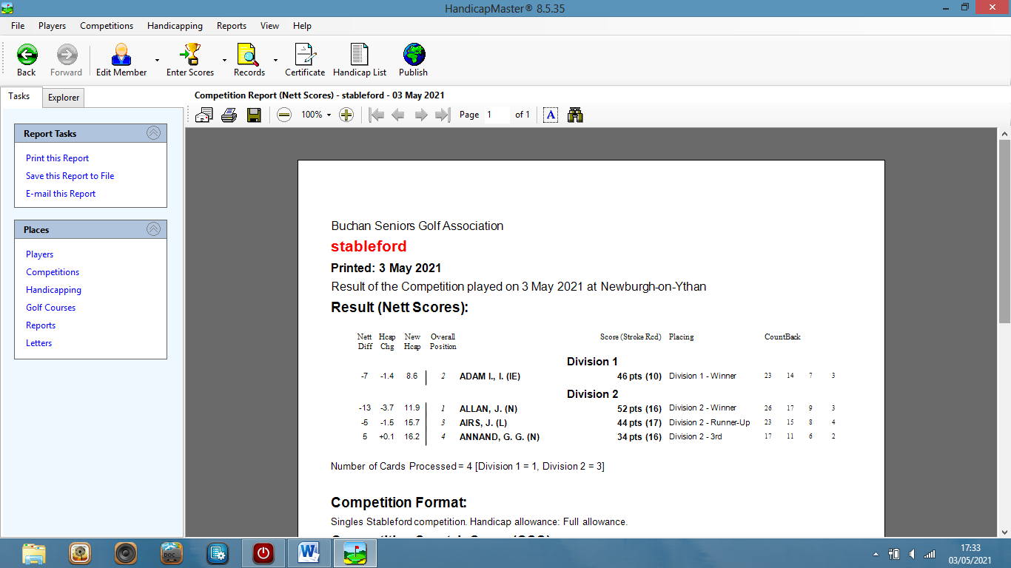
11.The Results Report will now be shown.
The competition is now finished and closed, so the RESULTS REPORT CAN BE SAVED ON TO A PEN-DRIVE.
It will also be saved onto the DATABASE RECORD in the final action as the program is closed and a BACK-UP MADE.

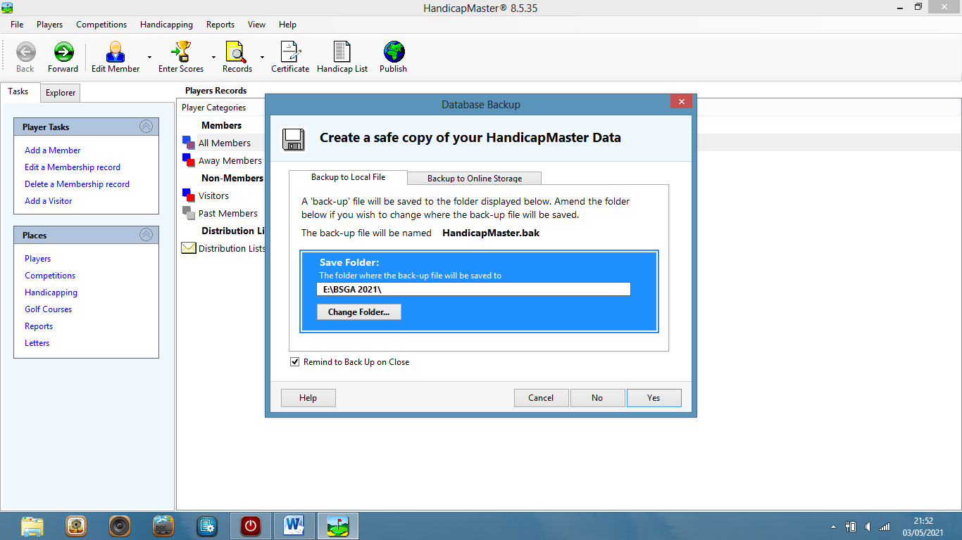
12. THE COMPETITION IS FINISHED AND RECORDED ON THE HANDICAPMASTER DATABASE WHEN YOU CLICK ON “YES”. Log-out.

R.McClymont May 2021

